Festival of Remembrance 2025 - Important Changes to the Ticketing Process

Festival of Remembrance 2025.
In response to a motion proposed at Annual Conference 2024, and a subsequent review of the ticketing process, we are pleased to announce that ticketing will now be conducted through a ballot. This is to enhance the ticketing process for members and to ensure fairness, accessibility and inclusivity.
Key changes:
- Instead of tickets being bought on a first-come-first-served basis, members will have three weeks to enter a ballot for a chance to secure tickets through an online platform. This is to ensure that more members have a chance to secure tickets.
- After the ballot closes, tickets will be allocated randomly by the online system.
- Unique payment links will be issued to successful applicants, providing a secure and streamlined payment process.
- Clear communication will be provided on key dates and deadlines to help members stay informed.
- Members will be able to purchase a maximum of two tickets for either the afternoon or the evening performance.
You will need the following information to enter the ballot registration of interest form when it opens:
- Your membership number - this consists of all numbers and can be found on your membership card or on your renewal letter reminder (example below). If you cannot find your membership number, please contact Membership Services at membershipservices@britishlegion.org.uk.
- 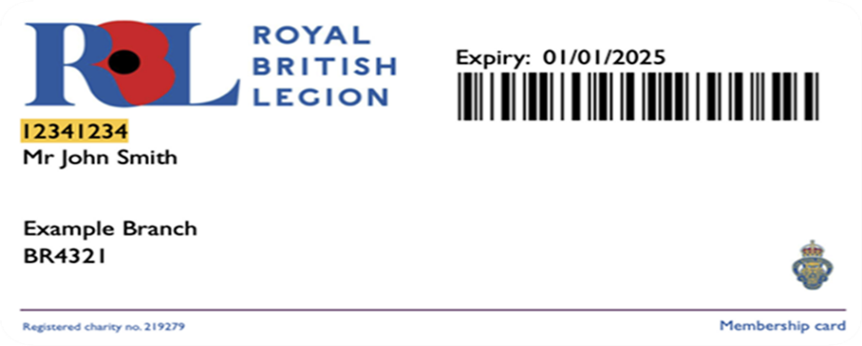

- A valid email address - ensure your registered email address is up to date, as all ballot communications will be sent via email. If you do not have your own email address, you can use one that belongs to someone else who has agreed to receive emails on your behalf e.g. a family member, trusted friend or neighbour.
Ballot rules:
- Each member is allowed to enter the ballot once.
- Successful applicants will be notified by email.
- Unique payment links will be single-use and must be completed within seven days from the date received.
- Other Ballot Rules can be found on our website.
Key dates:
- Ballot Registration Form opens: Wednesday 4th June 2025
- Ballot Registration Form closes: Tuesday 24th June 2025
- Ballot starts: Wednesday 9th July 2025
- Successful members notified from: Thursday 10th July 2025
- Payment links sent from: Thursday 10th July 2025
- Payment deadline: seven days from the date the payment link is received
- Tickets distributed from: Tuesday 28th October 2025
We encourage all members to review the updated process on the RBL website and keep an eye out for further updates, including the launch of the ballot in June 2025.

View the website

Thank you for your support of the RBL, our beneficiaries and our Armed Forces community.
Kind regards,
The Membership Team

