HYTHE AND SALTWOOD BRANCH – DEDICATION OF MEMORIAL BENCH
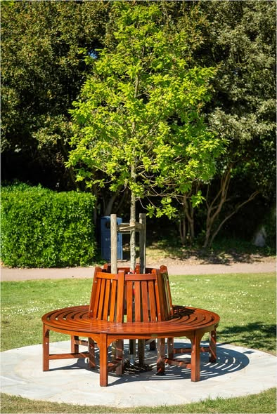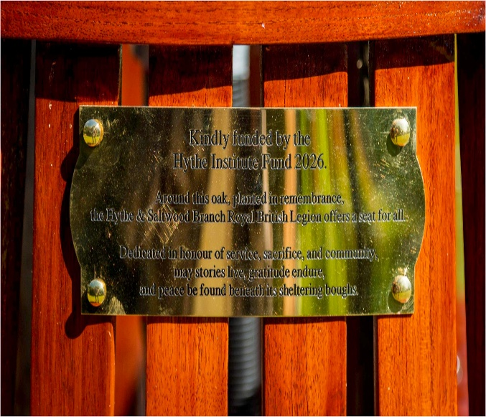

On Friday 24 April 2026, members of the Hythe and Saltwood Branch, alongside members of the local community and the RBL Kent County Chairman, gathered in Oaklands Park, Hythe, for a service to dedicate the Branch’s new Memorial Bench. Last year, the Branch planted a 14-year-old memorial oak tree and developed plans to surround it with a circular memorial bench. This service marked the successful completion of that project.
The short service was conducted by the Branch Chaplain, Dudley Shipton, with contributions from the Branch Chairman, Ian Norman; the Acting President, Joe Moran; and Barry Vincer.
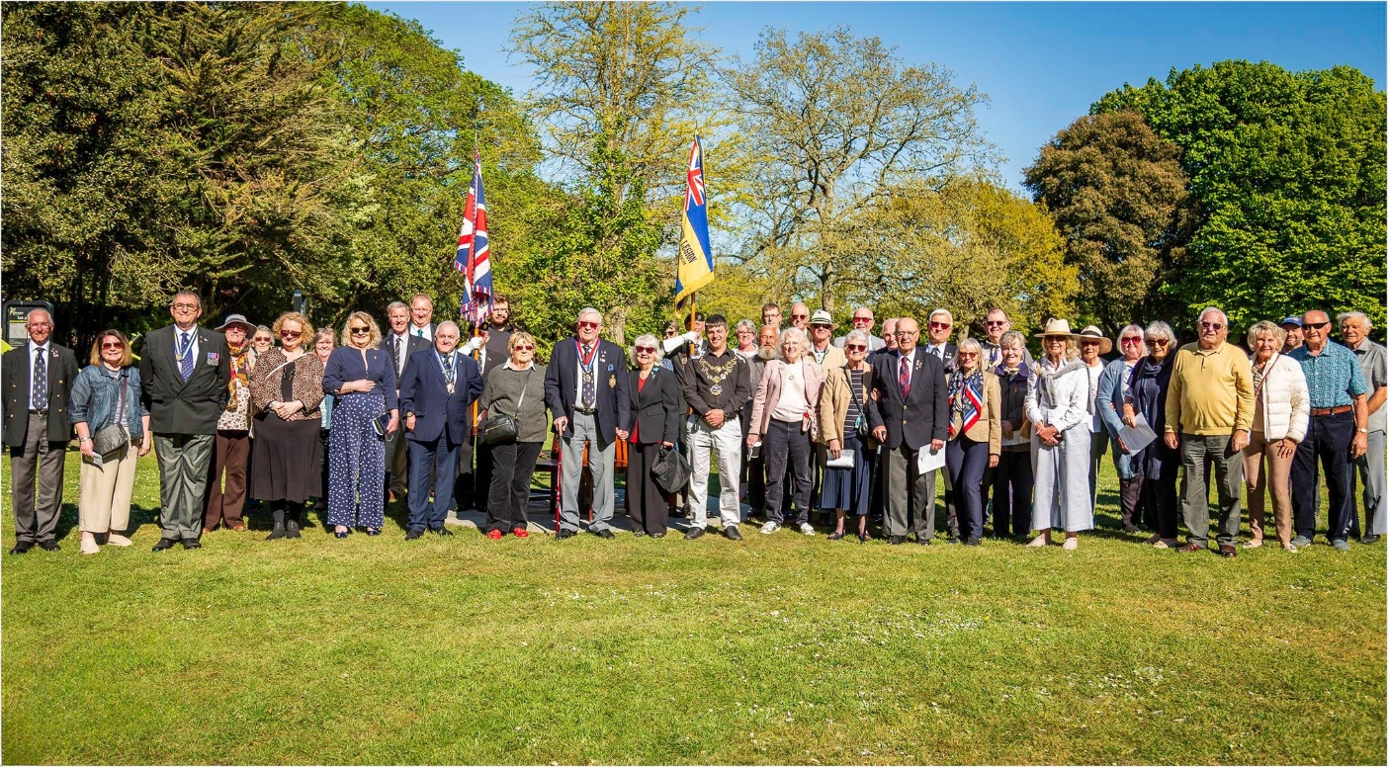
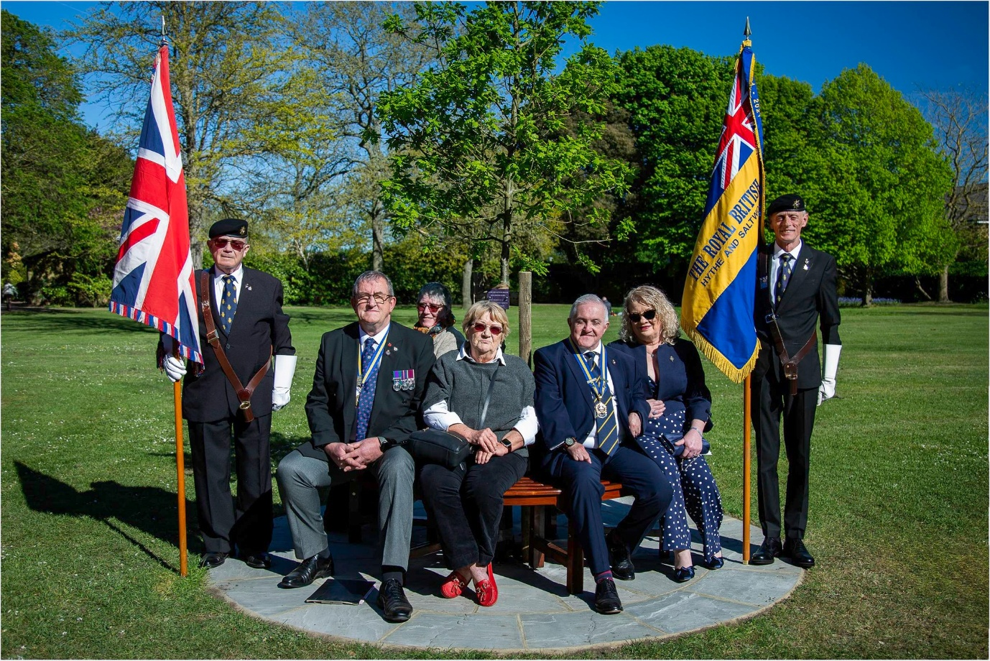
Following the service, attendees retired to the Hythe Albion Members’ Club, where a toast was raised “To The Fallen.”
The support of the Hythe Institute was crucial in bringing this Branch project to a successful conclusion; without their funding, the project would not yet have been completed. Sincere thanks are also extended to the dedicated installation team for their hard work over recent weeks, particularly David and Arthur Turner, Barry Vincer, Ethan Bedford, and Alan Richardson.

