HYTHE AND SALTWOOD BRANCH VISIT TO THE SOMME

Earlier this year, the Hythe and Saltwood Branch were fortunate enough to receive an invitation from the President of the Somme Branch – Rod Bedford – to attend the 109th Commemoration of The Battle of The Somme from 30th June to 2nd July 2025. Branch members quickly agreed that this was a worthwhile trip to undertake and planning began in earnest.

After a few false starts, investigating the cost of coach travel - extremely expensive. The committee settled on a self-drive option and we were fortunate enough to be able to secure use of the Hythe Community Mini-Buses. This meant the Chairman and Secretary undertaking training to be able to drive the minibuses, and in the process becoming community volunteer drivers.

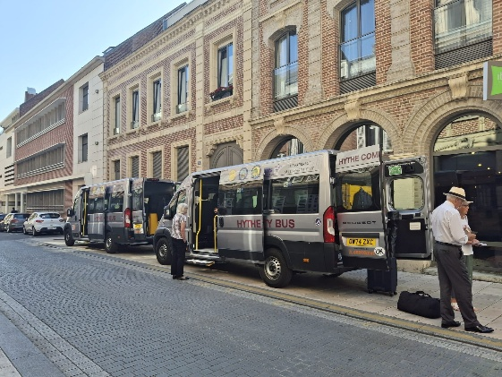
The Hythe Community Mini-Buses Outside Our Hotel

Twenty branch members and partners set off at 4:30AM on Monday 30th June 2025. Thankfully, it was only a short drive to the Le Shuttle terminal for our crossing to France, arriving a little after 8:00AM. Once off the shuttle, in France we set off for our 2-hour journey heading for The Ulster Tower. Once at The Ulster Tower, our Tour Guide gave a detailed description of the disposition of both British and German Forces on 1st July 1916, and it was quite clear that the German Forces had the advantage of the higher ground, he went on to describe the events of the day including the substantial losses suffered. Following this introduction, we passed the Connaught Cemetery on our way to the Thiepval Woods to see for ourselves what life may have been like for our soldiers. Replica trenches were viewed and we were able to glean some idea of life in the trenches.

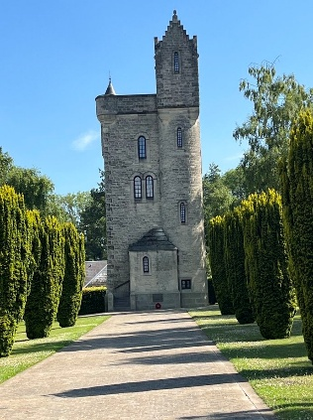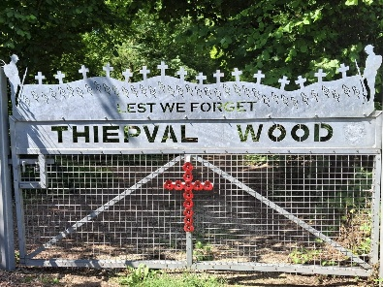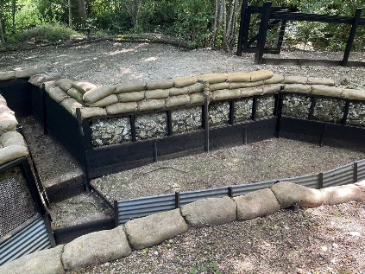
The Ulster Tower Entrance To Thiepval Woods Trench in Thiepval Woods

After a relaxing lunch break, our party then headed to our hotel in Amiens to check in, rest up and get ready for the 109th Commemoration Gala Dinner in the Royal Picardie Hotel in Albert.

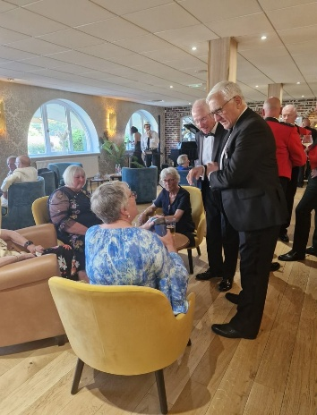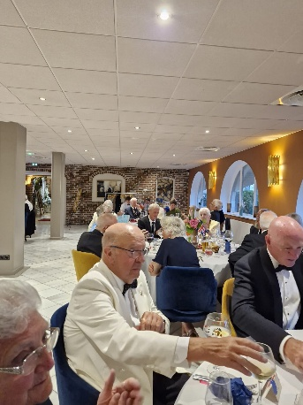
Branch Members at The Gala Dinner
The dinner was a fitting event giving our members the opportunity to meet and network with a number of individuals and groups. Following a delicious meal and some excellent entertainment our, by now, weary party headed back to the Hotel in Amiens for some well-earned sleep.

Tuesday morning dawned bright and hot. Branch Members assembled for a hearty French breakfast before heading to the Thiepval Memorial for the start of the day’s commemoration events. Our Standard Bearer, Alan Richardson was on parade carrying the Branch Standard with his usual aplomb and Bill Milner carried the Union Flag on behalf of the Somme Branch. Standards and the VIPs were marched on to the skirl of an Ulster Piper. Then during a sombre and thought-provoking service, our Branch President, Major (Retd) Dennis Bradley BEM DL, delivered the Exhortation and the President of the Somme Branch, Rod Bedford, the Kohima Epitaph. Subsequent to the laying of wreaths by the VIP dignitaries our new Branch Vice-Chairman, Barry Vincer, laid a wreath on behalf of the Branch and Ian Norman laid a poppy posy on behalf of his Great Uncle who is named on the Thiepval Memorial. If any of you have not yet visited the Thiepval Memorial, it dominates the skyline of the area and can be seen for miles around. It is an extremely fitting memorial to the missing of The Battle of The Somme. After the service our members were hosted to a vin d’honor in the garden of the cottage by the entrance to the Memorial.

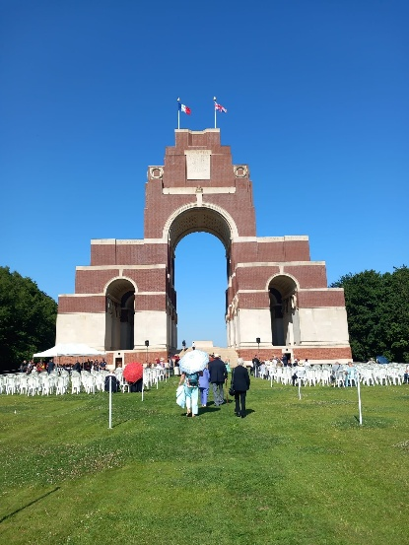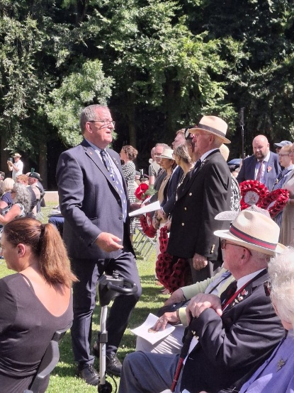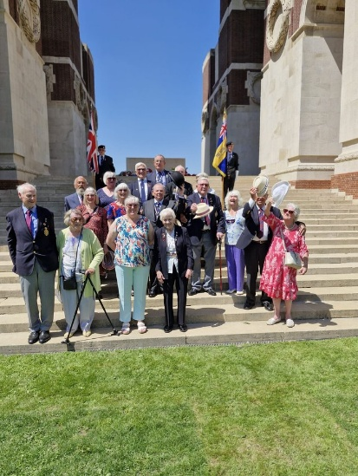

Thiepval Memorial Our Chairman organising the Wreath Layers Branch Members after The Service
In the afternoon, we attended the memorial service at the Ulster Tower, to the sound of an Ulster Flute Band marching ahead of the Standards. Following the service, members witnessed the laying up of the Somme Branch Standard.

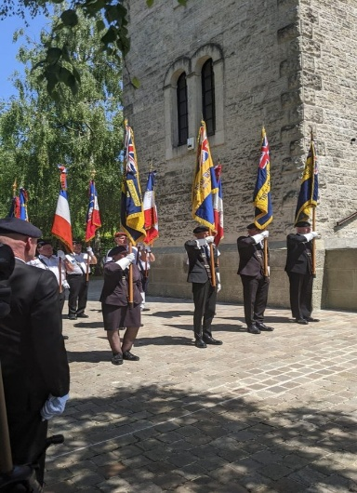
Standards on Parade at The Ulster Tower

A barbeque hosted by Rod Bedford gave branch members the opportunity to chat with the Legion Chief of Staff – Colonel (Retd) Clare Waterworth MBE and the open discussion saw them come away with a valuable insight into and a renewed enthusiasm for our shared mission. It also strengthened our sense of community and purpose. Finally, our extremely hot and by now exhausted group returned to our hotel to drink our own toast to ‘The Fallen.’

On our final day in France we started by visiting the Newfoundland Memorial, where we were treated to a wonderful resume of the Canadian involvement in the events of 1st July 1916, by a very knowledgably young volunteer Canadian Student. One of our branch members, Penny Burns, laid a Poppy Posy following a brief service.

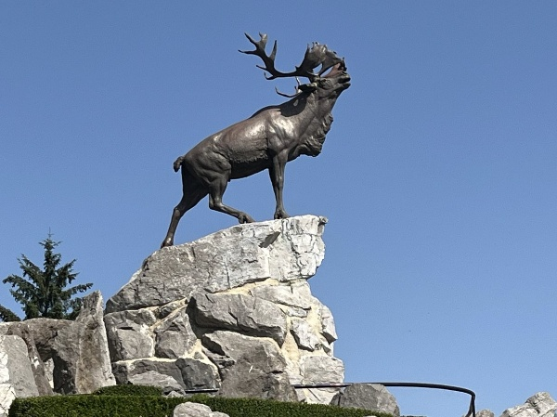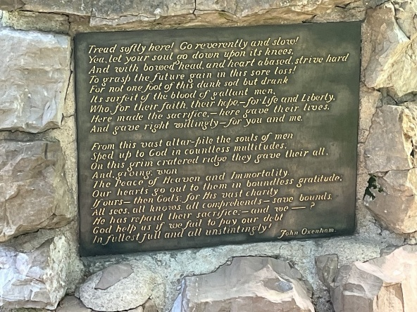
The Newfoundland Memorial Verse By John Oxenham at The Newfoundland Memorial

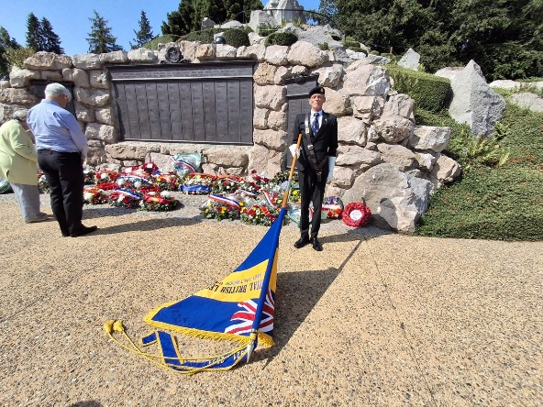
Penny Burns Laying a Poppy Posy at the Newfoundland Memorial

We later stopped at both the Ancre British Cemetery where Barry Vincer laid a poppy posy on the grave of a fallen soldier from Hythe and at Grandcourt Road Cemetery, where our Secretary, Squadron Leader (Retd) John Healey MIH, laid Poppy Posy on the grave of his Great-Grand Uncle, Lance Corporal Arthur Brown of the 2nd Battalion South Lancashire Regiment. The fact he was buried here was unknown to John prior to the planning of this trip. Grandcourt Road Cemetery was not the easiest to get to; having to drive the mini bus up a farm track, then walk across several fields to get there. That said the Cemetery has a commanding view over the local area.

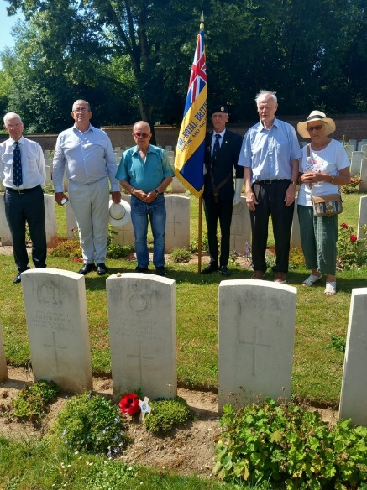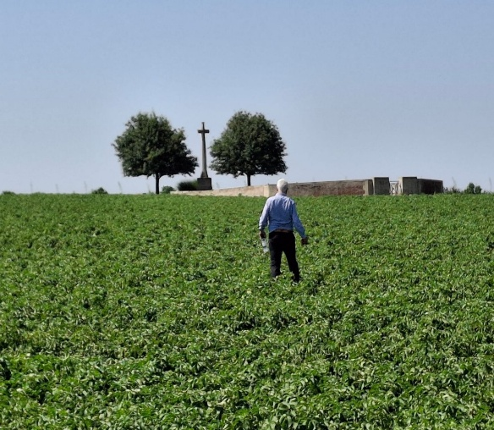
Laying a Poppy Posy at Ancre British John Healey Walking Across a Potato Field to Lay a Poppy
Cemetery Posy at Grandcourt Road Cemetery

After that, our intrepid travellers moved on for a hearty lunch at Le Poppy in Ovilliers La Boiselle,

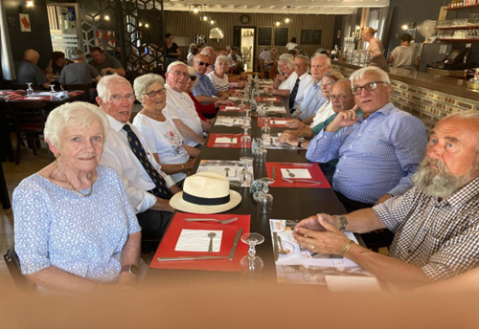
Final Day Lunch at Le Poppy

before starting the penultimate stage of our trip to Ypres and the Menin Gate.

Having arrived in Ypres we paraded at the Menin Gate for a short service, with the Branch Standard flying and our Chairman, Ian Norman, laid a wreath on behalf of the Branch. A short drive then saw us boarding Le Shuttle for our trip back to Blighty.

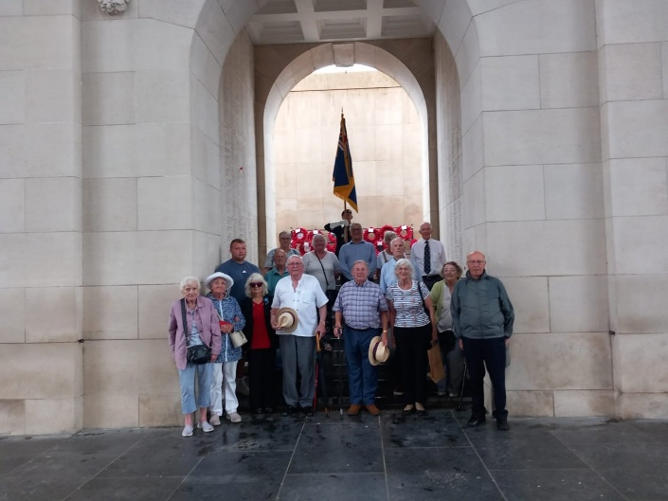
At The Menin Gate

Our thanks, as a Branch, go to Rod Bedford and his team at Somme Branch for the kind invitation and very generous hosting. Thanks also go to our Chairman and Secretary for both organising the trip and acting as drivers throughout.

Everyone agreed that our trip was extremely thought-provoking, evocative and brought home the horrors of World War One. If any of you reading this are contemplating a visit to The Somme and/or Ypres, my advice to you is to do it now – you won’t regret it.

