

Woodhall Spa

Royal British Legion

Branch No. BR0193

Newsletter - October 2023
Branch Officers

President: David Mullenger – 07881 712260
Chairwoman: Gill Hodgson – 07538 545409
Vice Chairman: John Egleton
Secretary: Martin Cox – 07760 258054
Treasurer: Andy Wilkes
Membership Officer: Carolyn Smith
Press Liaison Officer: Vivienne Simpson

Royal British Legion Helpline – 0800 802 8080

A note from our Chair

As we head towards our AGM I wish to thank the current committee for all their hard work and as some committee members step down, I am really pleased to say we have attracted 3 new recruits!

When I took the role of Chair last October I said that I wanted to see our branch thrive, not just survive, and I think we can agree that as a branch, we have done well! We have increased our visibility and professionalism with our new gazebo and associated kit, we have 94 branch members, we have had excellent fun at our branch meetings and a visit to the National Memorial Arboretum.
None of this would have been achieved without your individual and collective positivity - Thank you to all who have attended a meeting or event, or helped in any capacity.

We intend (unless challenged - form an orderly queue!) to give this another 'run round the block' and we look forward to more happy branch times together.

As we head into Autumn and Remembrancetide, and as the evenings draw in, I ask you to keep an eye on each other and report any needs for assistance to the committee to action.

Thanks again folks, together, We Will Remember Them.

Gill

 | Diary of Upcoming Events  10th October 7pm – Branch AGM (Members only) Woodhall Conservative Club  10th October 8pm – Poppy Awards & Member Recruitment night (All Welcome, buffet included)  28th October – Poppy Launch at East Kirkby Airfield  8th November 7pm – Spa Singers Remembrance Concert at St Peters Church  11th November 11am – Wreath laying at Woodhall Spa Memorial  12th November 9.30am – Remembrance Sunday Church Service & Parade  12th November 12.30pm – Post Remembrance Lunch at The Inn  14th November 7pm – Branch Meeting  12th December 7pm – Branch Christmas Party with buffet & entertainment
 |  | 
New Gazebo  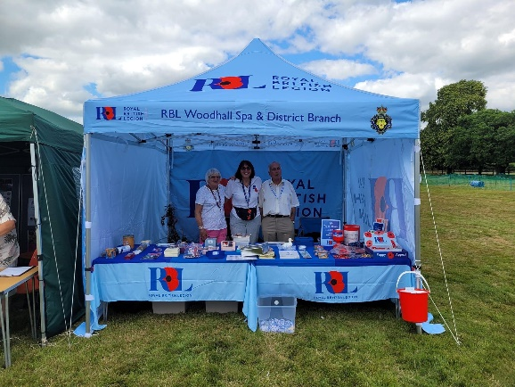  Thanks to the generosity of members and funds from other sources a new marked up gazebo has been purchased and has been used at fete’s in Bardney, Martin & at the 1940’s Woodhall Show. We are definitely looking the part now it’s a great asset and totally waterproof. Thank you to everyone who made this possible. |  |  | Poppy Launch  The launch of the Lincolnshire Poppy Appeal will be taking place at the Lincolnshire Aviation Heritage Centre on 28th October. The service is held by the Royal British Legion in the hangar under the nose of the Avro Lancaster NX611 ‘Just Jane’. Please be in your seats by 10.50am, service starts at 11.00am. There is a Lancaster taxy run at 2pm & 4pm. The aviation centre hope to provide a poppy drop from the Lancaster with 50’000 poppies at 2pm  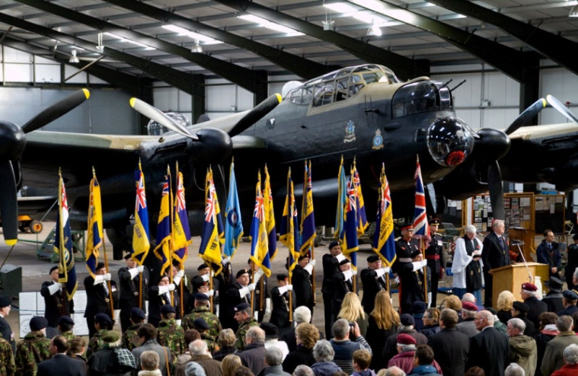

Successful Member Social Evenings & Events

We have held some successful members social evenings this past few months that have been well attended and thoroughly enjoyed by all in attendance. A number of our members also had a successful adventure to the National Memorial Arboretum in July. Below are just a few photo’s from some of these events.

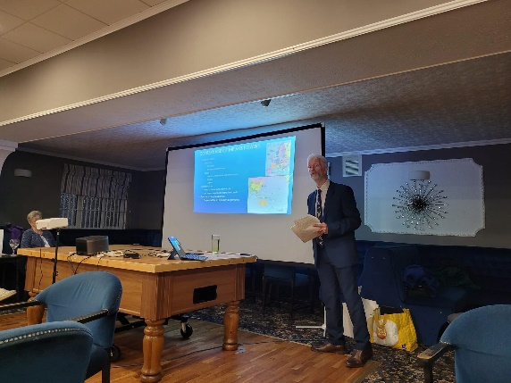  Simon Kemp – BBMF about the Battle of Britain | 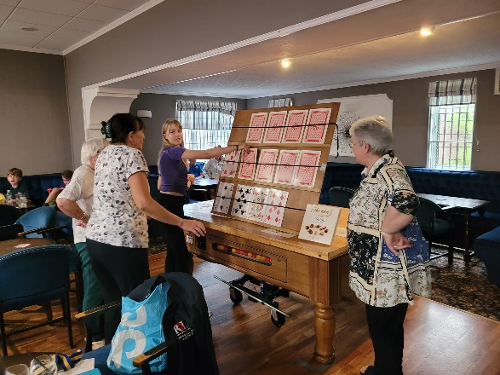  An evening of Play your Cards Right
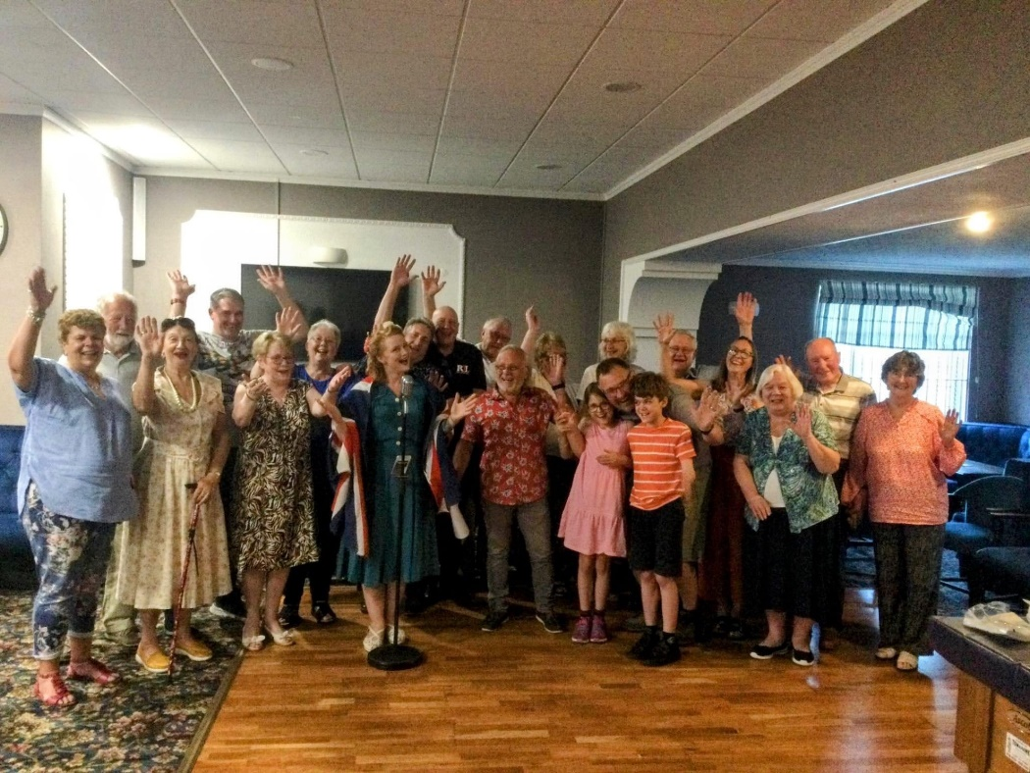

Always popular an evening with Miss Sarah Jane

In Memory

We pay our respects to two of our long standing members Margaret Macnaughton & Pearl Elston who we have sadly lost. Our thoughts and greatest respects are sent to their families.

Korean Veterans’ Service – Sunday 30th July 2023

On Sunday 30th July Horncastle Hamerton Gardens saw the annual service to remember the signing of the armistice that ended the fighting of the Korean War in 1953. Martin Cox was standard bearer for our Branch and other members of our Branch honourably represented us. Representatives of the South Korean Embassy in London and the 3 remaining Lincolnshire veterans were also in attendance.

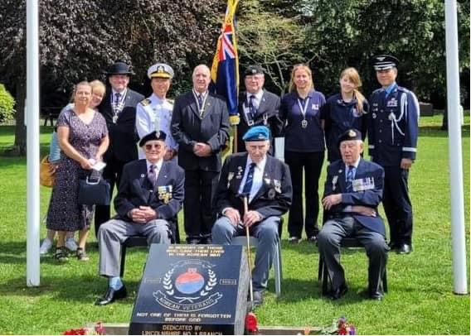

Branded Clothing

If any members are interested it has been mentioned about branded clothing being available.

There is a Polo Shirt & Jacket that are available, with the RBL Branch logo on. If anyone is interested please let Martin know, the cost of the Clothing will be:

Polo Shirts £17.50
Jackets £27.50

If you would like anything adding to the next Newsletter then please email woodhallspa.secretary@rbl.community and mark for the attention of Cath Conway.

