Branch Commemoration and Awards

In addition to our monthly Branch meeting, we also have periodic social events. We join with the Kent Grenadier Guards Association for lunch 6 times a year in St Edwin’s Lodge, and recently held a Celebration event to honour hard working members of the Branch, and to pay tribute to our outgoing Branch President and recently retired Branch Chairman.

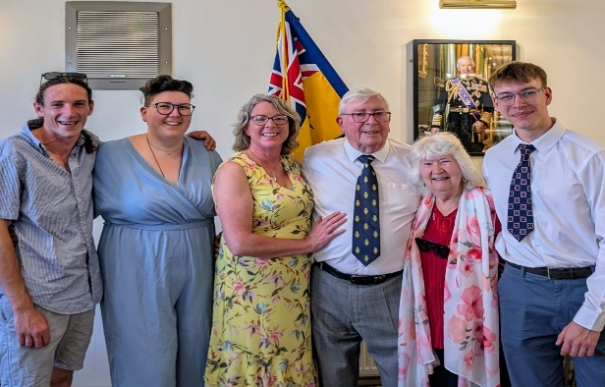

Branch President

The Branch proudly paid tribute to its esteemed outgoing President, Mr Joe Moran, celebrating over 60 years of continuous service to the Branch marked by his leadership, compassion, and unwavering dedication to remembrance.

Joe, who joined the Branch in 1962, was honoured during a formal ceremony attended by fellow Branch members, dignitaries, members of the wider community and his family. The tribute highlighted his foundational contributions as Assistant Standard Bearer, his tireless efforts in leading the Poppy Appeal for over 55 years, and his far-reaching welfare work, which continues today through his involvement in the Dementia Forum.

One of the most memorable anecdotes shared recalled Joe’s 1966 intervention on behalf of a WWI veteran, resulting in a £1,000 award and a war pension—a reflection of his extraordinary advocacy. His role in securing and preserving vital community spaces, including the relocation of the Canadian hut, the building of the Branch hall in 1976, and the transfer of the clubhouse to Hythe Sports and Social Club, was also formally recognised.

The ceremony acknowledged Joe’s ceremonial leadership during national moments, including milestones in Her Late Majesty Queen Elizabeth II’s reign, and honoured his personal connection to military history through his cousin’s service in the Falklands War alongside Colonel H. Jones VC.

A heartfelt tribute was also paid to Mrs Eve Moran, whose support and quiet strength have stood behind Mr Moran throughout his decades of service.

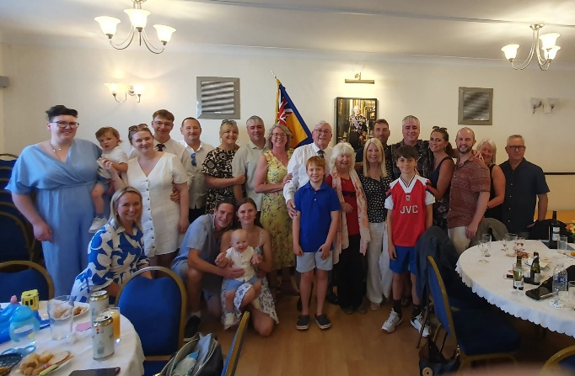
In closing Joe was presented with a commemorative gift on behalf of all Branch members, past and present, symbolising deep gratitude for his enduring legacy.

“Joe has carried our standard, built our halls, cared for our people, and honoured our history. His name is etched not only in our records, but in our hearts,” said the current President Major (Retd) Dennis Bradley MBE DL, during the closing remarks.

Branch Chairman

The Branch proudly honoured Major (Retd) Keith Miles for his outstanding service and leadership during his tenure as Chairman. With a legacy spanning community engagement, historical preservation, and youth education, Keith’s contributions have left an indelible mark on the branch and the town it serves.

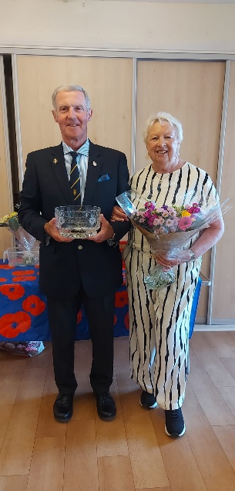

During his time in office, Keith represented the branch at multiple County Conferences, where he spearheaded the successful proposal to introduce a Roll of Honour—a solemn reading of names of recently deceased Legion members. This tradition has since been adopted in printed format, ensuring each name is remembered with dignity.

Keith also played a prominent role in commemorative events such as Canada Day services at Shorncliffe Military Cemetery, strengthening ties with Commonwealth allies and upholding the spirit of international remembrance.

To mark the branch’s 100th anniversary, Keith led the renewal of the official Standard and coordinated the laying up of the old Standard at St Leonard’s Church, reinforcing the ceremonial heritage of the Legion.

As Chairman of the Hythe War Memorial Poppy Committee in 2017–18, Keith guided the design, fundraising, and installation of the Poppy sculpture commemorating the centenary of the end of the First World War. The memorial remains a community landmark, with residual maintenance funds held in trust by the District Council—testament to careful planning and lasting impact.

Keith also partnered with Susan Foster to engage with local youth groups including Cubs and Scouts, forging affiliations and supporting Poppy-making evenings to teach values of remembrance and military service.

Most recently, Keith represented the branch at the installation of the new Lord Warden of the Cinque Ports, reaffirming the branch’s civic role and historic ties to the Cinque Ports confederation.

The branch also warmly acknowledges Pat, whose unwavering support has been a quiet yet essential presence throughout Keith’s tenure. Her dedication and kindness have uplifted members and strengthened the branch in meaningful ways.

“We thank Keith for his steadfast leadership, and we thank Pat for walking alongside him every step of the way,” said the current Chairman Ian Norman speaking at a recent branch ceremony. “Their contributions exemplify the spirit of service and remembrance we all hold dear.”

