
Website https://branches.britishlegion.org.uk/branches/rushden/

RBL RUSHDEN BRANCH NEWSLETTER FOR DECEMBER 2025

CHAIRMANS’ CHRISTMAS MESSAGE In my Christmas message last year, I said 2025 will bring us new and exciting challenges; well, it most certainly did with the 80th Anniversary of both VE & VJ Day, the 85th Anniversary of the Battle of Britain and the bombing of Alfred Street School, now called Alfred Lord Tennyson School, which is affiliated to our Branch. Apart from Remembrance tide, they were the key remembrance times, not to mention of course Holocaust Day and Merchant Navy Day. Due to the constant support throughout the year from a good dozen or so members and a handful of other members, we have been successful in fundraising for both the Poppy Appeal and Branch Funds; this is up to and including the recent Rushden Christmas Lights Switch On. Thank you; you have helped our service personnel, our veterans and/or their families somewhere along the line. That support is vital, and we need more members to get involved, even if it means just two hours a year helping to run an RBL stall. It is not only satisfying for one to know they have helped and maybe made a difference in somebody’s life, but that two-hour stint also offers a bit of a break for the volunteer manning the stall at the time. We will need help from early summer 2026 onwards through to next year’s Christmas Lights Switch On. Please give up just two hours. Our Poppy Appeal Organiser’s (PAO) team in Ruth Miller and her husband Steve the Deputy PAO, have pulled off a fantastic Poppy Appeal 2025 by raising more than £49K with money still to come in. To their fantastic army of volunteer fundraisers (including Sally Morton & Heather Phillip’s Lidl team), many of whom are not legion members, I wish to thank you all on behalf of the Branch. You’ve done an amazing job; the people of Rushden and the surrounding areas are great supporters of the military community and are equally thanked. Many will have heard me read out at the recent AGM or have read my Chair’s Report concerning our future as a Branch; I shall not dwell on that, suffice to say if we, the incumbent Committee Members decide not to seek renomination after our three-year tenure expires in November 2026, we will need a new Committee and if we can’t do that, we will become a County Supported Branch – a situation no branch wishes to happen. Please think about joining the Committee – come for a taster session and see what we’re all about. In closing, I wish everybody a Very Happy Christmas and a Happy, Healthy, Prosperous and Safe New Year.

IMAGES OF REMEMBRANCE
Attached to this e-Newsletter is a collection of “Images of Remembrance 2025” for you to see, reflect upon and remember. The printing of these images for 20 members who receive a printed Newsletter would incur a huge cost so, regrettably, they’re not attached for those recipients; they will be available for perusal in the Branch Secretary’s Folder at Branch Meetings.

BRANCH SOCIAL – 8th DECEMBER 2025
We’ll see you at the Athletic Club – Bar opens at 7pm with a Christmas theme of course. Bingo, Quiz, Cornhole, Music, Food and a Raffle will be held.

Remembering Bosnia
On the 14th December, the Royal British Legion remembers the 30th anniversary of the end of the Bosnian War, and the crucial contribution of British Forces in the international efforts to secure and maintain peace, including NATO’s first peace-support mission. A special commemorative event will be held at the National Memorial Arboretum.
Following the end of the Cold War, the disintegration of Yugoslavia saw its republics declaring independence. Bosnia and Herzegovina (Bosnia) had a shared government reflecting its mixed ethnic composition with a Bosnian Muslim majority. In a referendum the overwhelming majority voted for independence in March 1992. A potential Bosnian nation that had a Muslim majority was opposed by Bosnian Serbs, who launched military action to secure territory and began a systematic programme against the Muslim population. They also targeted Bosnian Croats. The subsequent civil war saw bitter fighting; and emerging accounts of atrocities alarmed the international community.
First British Forces Arrive - In September 1992, the United Nations authorised the deployment in Bosnia of a multinational Protection Force, with the first British ground forces arriving soon after. These, and subsequent units, were sent to protect vital convoys of food and medicine, monitor ceasefires and patrol and gather intelligence. Later duties involved overseeing designated safe zones the challenges of mine clearance and infrastructure rebuilding.
The personnel from the UK and other countries were frequently on the front lines, and between the combatants of an unremitting war which saw indiscriminate shelling of towns and cities such as the Bosnian Serb siege of Sarajevo where more than 11,000 people were killed. The conflict also saw the committing of war crimes. These included massacres and UN-recognised genocide (most infamously at Srebrenica where 8,000 Muslim men and boys were killed).
RAF and Fleet Air Arm pilots served as part of NATO’s enforcement of a no-fly zone and carried out air strikes to protect UN-designated safe havens. The fighting ended after a 12-day NATO air campaign against Bosnian Serb targets paved the way to a peace agreement, the Dayton Accord, which received its final signatures on 14th December 1995. More than 100,000 people had been killed, and 2.2 million (more than half the population) displaced across the region.
NATO’s First Peace-Support Mission - Under the terms of the peace agreement, NATO deployed peacekeepers for the first time, leading a 60,000-strong Implementation Force (IFOR), including thousands of British men and women. In a year this was replaced with the smaller Stabilisation Force (SFOR) and as stability returned troops were progressively withdrawn. By 2020 UK personnel had been withdrawn, although specialists in security remain and British forces engage in training exercises with their Bosnian counterparts.
A total of 36 NATO and partner countries had contributed troops and had suffered hundreds of military and civilian casualties in the operations. British forces lost 59 military personnel, and many dozens were seriously injured. The harrowing nature of the security work resulted in many suffering from trauma, including PTSD, and they continue to live with the impact of what they witnessed.
We pay tribute to the men and women of British forces who served in Bosnia and Herzegovina, and we are privileged to tell their stories of service in a changing world. See more about those stories by clicking here Remembering Operations in Bosnia

RDVG BURNS NIGHT – 24TH JANUARY 2026
There is going to be another Burns Night at The Masonic Hall, Wellingborough Road, Rushden, on Saturday 24th January 2026, 7pm for 7.30pm. This is being organised by the Rushden & District Veterans’ Group (RDVG) and so another great opportunity to enjoy Scottish Poetry, Bagpipes and good, clean and jovial fun awaits us. The cost will be £33 a head; this event is open to the public and has been advertised in social media. The RDVG will need to know who is coming and whether there are any special dietary requirements, such as gluten free, vegan, nut allergies, etc. Thanks for those members who have already put their names down on the list; it will be made available for members at the Branch Social Evening on 8th December. Spread the word, tell your friends and family who must be over 18 years of age. Please be sure to put your name down if you wish to attend, making note of your dietary needs. Don’t miss out on what promises to be another great Burns Night out!

RBL HELPLINE – 0808 802 8080 - CALL 8am to 8pm 7 DAYS A WEEK

WHAT ELSE IS GOING ON IN THE NEXT FEW WEEKS & INTO THE NEW YEAR?
Second Monday of every month except March, June, September and December
– Branch Monthly Meeting at the Athletic Club commencing 7.30pm.

NOTE: New Format of Branch Meetings is not expected to exceed 25 minutes!

The next Branch Monthly Meeting is on 12th January 2026, which will be followed by Paul Barwick talking about “The White Mouse (Nancy Wake)”, a nurse and journalist who joined the French Resistance and was a WW2 SOE operative. The meeting after that is on 9th February 2026, where the Speaker will be Nick Cooke about “The Great Train Robbery.”

Fourth Tuesday of every month – No Group Meet in December 2025. The Community Social & Craft Group meet at the Rushden Athletic Club on Newton Road, between 1pm and 3pm. RAFA Members Free. Guests £3/entry or £20 per year. This is open to any RBL Rushden Branch Member. For more information contact Carol on 07922 141589 or carol.easton12@gmail.com Next meet is on 27th January 2026.

Every Wednesday & Saturday Morning – 9am start. Northants Breakfast Club (NBC) dine at The Needle and Awl. All Veterans are welcome. Families are invited to join on the last Saturday of each month, namely 27th December and 31st January 2026.

First Thursday of every month – 1st January – TBC by BCC: 10am to 12.30pm – Friends of the Legion meet at The Athletic Club, Newton Road, Rushden. Pop along for a cuppa and a chat any time between 10am and 12.30pm. The next meet is on 5th February.
Second Thursday of every month – 11th December 2025 - 9am start - NGH Breakfast Club at Northampton General Hospital, Cliftonville, Northampton, NN1 5BD. Eat Street is the hospital restaurant on the main corridor through the hospital opposite the Chapel. The Breakfast Club is open to all veterans (staff, patients and public). Attendees to purchase their own breakfast and drinks. The next NGH Breakfast Club meet after this month’s is on 8th January 2026.

NEW – Last Thursday of Every Month – 29th January 2026 - 10am -11.30am – Bilton Court Care
Home would like to invite you to their Veterans Coffee Morning at Bilton Court Care Home,
Queensway, Wellingborough, NN8 3FR. For more details phone 01933 401613 or pop in. The
next Veterans Coffee Morning is on 26th February.

Last Friday of every month – No group meet in December 2025 – 9am start – KGH Breakfast Club Kettering General Hospital, Rothwell Road, Kettering, NN16 8UZ. The Basement Brassiere is located on the lower ground floor of the main hospital building. The Breakfast Club is open to all veterans (staff, patients and public). Attendees to purchase their own breakfast and drinks. The next KGH Breakfast Club meet after this month’s is on 30th January 2026.

RBL WELFARE AND SUPPORT SERVICES

DO YOU

NEED ANY HELP, OR DO YOU KNOW A VETERAN OR RBL MEMBER WHO NEEDS HELP? IF SO, PLEASE CALL OUR BRANCH COMMUNITY SUPPORTER, PAUL MCKAY ON 07305 837099 OR VIA EMAIL (SEE THE LIST OF WHO’S WHO ON PAGE 10). YOU CAN ALSO CONTACT THE BRANCH COMMUNITY COORDINATOR, PETER ARMSTRONG ON 07498 243683. HIS EMAIL ADDRESS IS ALSO AT WHO’S WHO? REMEMBER, THE RBL IS HERE FOR YOU. IF THEY CAN’T HELP, THEY’LL GET YOU HELP. PLEASE BEAR IN MIND THAT EVERY SITUATION IS DIFFERENT.

WHAT’S ON IN 2026? PLEASE PUT THESE DATES IN YOUR DIARY, ESPECIALLY THOSE IN RED WHERE YOU CAN HELP OR HIGHLIGHTED WHERE ATTENDANCE IS ENCOURAGED

10th January – RBL Annual County Conference – Guildhall, Northampton
24th January – Rushden & District Veterans’ Group Burns Night
27th January – International Holocaust Remembrance Day
2nd to 4th May – East Midlands Steam & Country Show, Lancaster Farm, Chelveston
8th May – 81st Anniversary of VE Day
8th to 10th May 2026 – RBL Annual Conference - Brighton
27th June – Armed Forces Day by the Rushden & District Veterans’ Group
July TBC – Party in the Park
August TBC – Classic Car Show
13th August – 86th Anniversary of the Battle of Britain
15th August – 81st Anniversary of VJ Day
September TBC – Bark in the Park
3rd September – Merchant Navy Day
3rd October – 86th Anniversary of the bombing of Alfred Lord Tennyson School
5th November – School Children’s Garden Service of Remembrance at Rushden War Memorial
8th November – Remembrance Sunday Parade & Service
11th November – Armistice Day
16th November – Branch AGM
28th November TBC – Rushden Christmas Lights Switch On

AWARD OF THE BRANCH CERTIFICATE OF APPRECIATION
At this year’s AGM, Branch member Peter Armstrong relinquished his role as the Branch Community Supporter (BCS) after eight years in the role. Peter is staying on as the Branch Community Coordinator (BCC), so the branch remains fortunate to have both a BCS in Paul McKay and a BCC. Peter is pictured here below receiving his award from Branch President David Hawker.

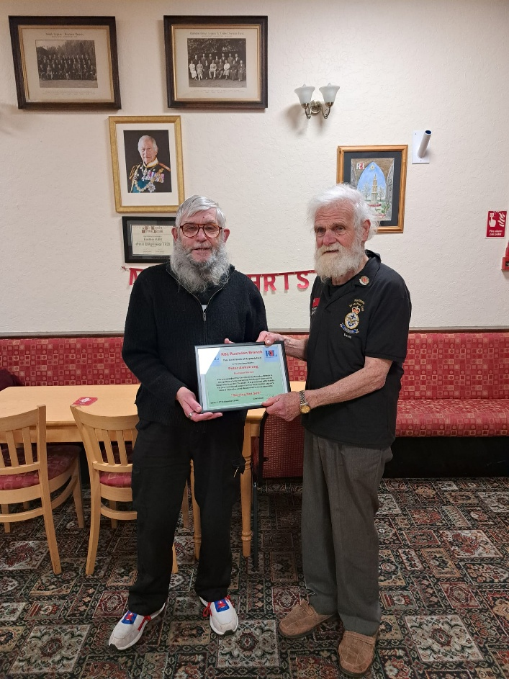
TALKING OF PETER ARMSTRONG -OUR BRANCH COMMUNITY COORDINATOR!

Also at the recent AGM, the Branch unanimously voted for Peter to be nominated to join the RBL County Committee to assume the role of County Youth Officer (CYO); he accepted and hopes to be appointed for up to 3 years.
The role involves supporting and liaising with youth organisations, helping them affiliate with the RBL, and encouraging youth involvement in Legion activities like the Poppy Appeal and Remembrance services. This position acts as a bridge between local branches, youth groups, and the wider RBL county and national bodies, facilitating communication, administrative processes, and collaborative projects to raise awareness and promote the RBL's work among young people.

BRANCH COLLABORATION WITH LOCAL CHARITY SERVE
RBL Rushden Branch continues to strengthen its ties with the local community. We already have a strong relationship with Rushden Town Council and the community in general by the reciprocal support offered to each other and the generous donations from this small town’s population of just 32,000.
SERVE is an award-winning registered charity in Rushden. It is over 40 years old and a voluntary organisation which supports independence, offers wellbeing activities, personal care, transport and domestic services and more to keep its beneficiaries safe and happy to live at home. It is dedicated to supporting older individuals, people with disabilities, and their carers. More than 1,600 service users, a team of 150 volunteers, 40 professional home carers and support provided to 350 unpaid family carers. SERVE offers a wide range of vital services daily making a positive impact to the community. A good proportion of these 2,000+ people are either veterans or families and relatives of veterans.
Currently, our Branch is undertaking a collaborative project with SERVE where some members who have got amazing stories to tell, whether it be their life story, a specific period or event, or even a brief story of their careers, will be taking up the Befriending Service, where a SERVE Volunteer comes to their home with an iPad or Tablet, and beavers away typing, whilst they tell their story. They could even upload some of those treasured photographs that would not even leave the member's house, visiting as many times as possible, and not just to get their story, but being a Befriender. All of SERVE's Befrienders are vetted formally through the Disclosure Barring Service (DBS).
SERVE's CEO, Tony Gibbs, approached our Branch to see if the RBL is happy to pay for one of SERVE's minibuses to be covered with poppy livery, which can then be seen and stand out all around the town and district and be positioned at various spots when not in use, not to mention be visible up to and beyond Armistice Day. Fortunately, the RBL saw this as a great way of promoting the RBL and Poppy Appeal, whilst at the same time promoting SERVE. The result of this latest collaborative project is here below, where it was prominently displayed for the public to see in front of Rushden’s War Memorial on Armistice Day 2025. Public response has been very positive.

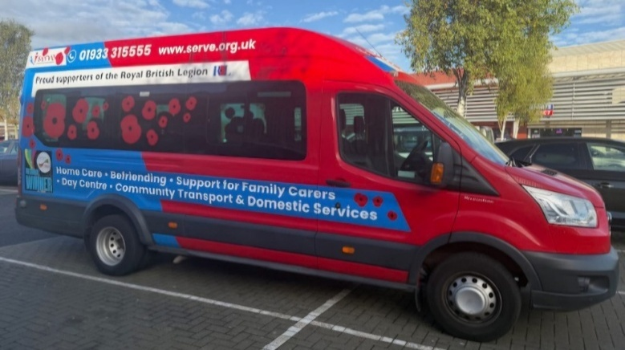
RBL Rushden Branch Committee, PAOs, PAM and CEO SERVE
Left to right: Paul McKay Branch Vice Chair and his wife Fiona, Sally Morton Committee Member, Janet Flowers Treasurer, Heather Phillip Committee Member, Ruth Miller Poppy Appeal Organiser and her husband Steve Miller Deputy Poppy Appeal Organiser and Committee Member, Barbara Clark former Poppy Appeal Organiser, David Hawker Branch President, Giles Coleman Poppy Appeal Manager, Lynne Baker Branch Secretary and her husband Jake Baker Branch Chair and Tony Gibbs CEO SERVE.

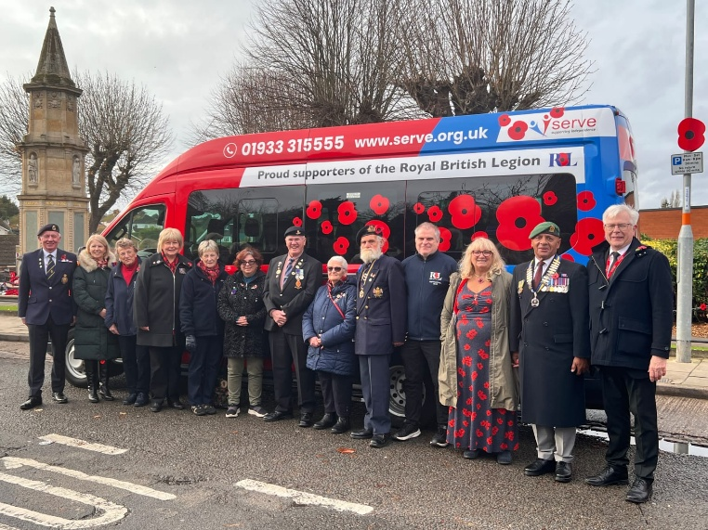

MISSION ACCOMPLISHED! DB Shoes Fitting Centre Rushden Supports Royal British Legion with 80 for 80 Campaign

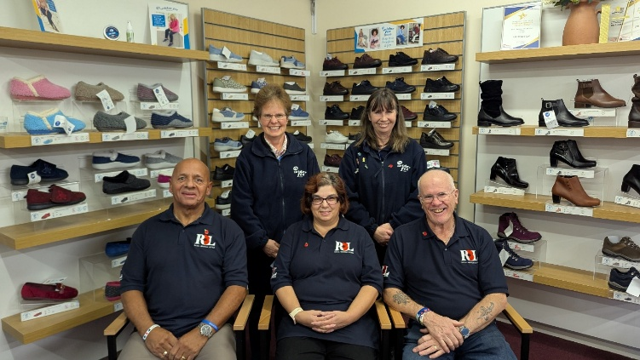
DB Shoes has successfully completed their ‘80 for 80’ campaign and given away 80 pairs of slippers and raised £400 for the Poppy Appeal. Thank you to everyone who supported this tribute to 80 years since WW2 ended.

The DB Wider Fit Shoes Fitting Centre in Rushden recently completed its special “80 for 80” campaign, commemorating 80 years since the end of World War II. As part of the initiative, the centre gave away 80 pairs of slippers to customers and donated £400 to the Poppy Appeal through the Rushden Branch of the Royal British Legion.
To celebrate the success of the campaign, the Fitting Centre welcomed Branch Chair Jake Baker and Poppy Appeal Organisers Ruth and Steve Miller for a photo opportunity with two members of the DB Shoes Fitting Centre team. The donation will help the Legion continue its vital work supporting service personnel, veterans, and their families.
Helen Denton from DB Shoes said: “We’re proud to support the Royal British Legion and honour the memory of those who served by making this donation to the Poppy Appeal. This campaign was a way for us to give back to the community while raising awareness of the Legion’s incredible work.”
On behalf of us all Jake expressed his gratitude for the generous contribution to the Poppy Appeal and the ongoing support from local businesses like DB Shoes Ltd.

RBL ANNUAL COUNTY CONFERENCE 2026 – 10TH January 2026
This conference takes place in the Great Hall, Guildhall, Northampton NN1 1DE on Saturday 10th January 2026. Arrive by 1000 hours for 1030 hours start. Members are encouraged to attend this event which finishes at lunch time. It is a great way to understand more about the RBL and listen to speakers from the RBL, see awards and presentations, etc. If any members are interested in attending, please contact any Committee Member at the Branch Social or via Branch Secretary Lynne Baker’s email address rushden.secretary@rbl.community or call Branch Chair Jake Baker on 07525 441267 by close of play 10th December 2025 as returns must be submitted by then. Transport can be arranged to collect members from home and return home after Conference to home. All attendees please note:
• Please allow enough time on arrival for parking in the nearest public car park (St John’s)
• There are disabled parking bays in St Giles Street and Abington Street
• Entrance to the Great Hall for all delegates and visitors will be signposted
• Dress will be uniform, lounge suits or blazers, medals may be worn
• The conference may be recorded for minuting purposes
• Official photographs may be taken during the Conference

TIME FOR A BIT OF HUMOUR!!🤣

A priest, a pastor and a rabbit entered a clinic to donate blood. The nurse asked the rabbit: “What’s your blood type?” “I’m probably a type O”, said the rabbit.
I don’t have an advent calendar, so I’m just opening cupboard doors and eating whatever’s in there.

Bought myself a First Aid Kit for Christmas………thought I’d treat myself!
How to survive falling down a staircase……A step-by-step guide.
I’m reading a book about anti-gravity. I just can’t put it down!
I did a theatrical performance about puns. It was a play on words.

WHO’S WHO IN OUR BRANCH?
President - David Hawker: via rushden.secretary@rbl.community
Chair/Media Rep: Jake Baker rushden.chairman@rbl.community 07525 441267
Vice Chair – Paul McKay: rushden.vicechairman@rbl.community 07305 837099
Secretary – Lynne Baker: rushden.secretary@rbl.community
Treasurer – Janet Flowers: rushden.treasurer@rbl.community
Standard Bearer - Mark Taberner-Stokes: via rushden.secretary@rbl.community
Committee Member – Heather Phillip: via rushden.secretary@rbl.community
Committee Member – Sally Morton: via rushden.secretary@rbl.community
New Committee Member – Ray Burke: ramondo4@yahoo.co.uk 07853 085368
Committee Member – Steve Miller: via rushden.secretary@rbl.community
Branch Padre – Pauline Cook: richardpaulinec@yahoo.co.uk 07871 923337
Deputy Branch Padre – Richard Cook: richardpaulinec@yahoo.co.uk 07871 923337
BCC – Peter Armstrong: parmstrong.bcs@rbl.community 07498 243683
BCS & BCC – Paul McKay: rushden.bcc2@rbl.community or rushden.vicechairman@rbl.community also PMcKay.BCS@rbl.community You can also call him on 07305 837099
Poppy Appeal Organiser – Ruth Miller: poppyappealrushden@gmail.com
Deputy Poppy Appeal Organiser – Steve Miller: poppyappealrushden@gmail.com

RBL ANNUAL NATIONAL CONFERENCE – 8TH – 10TH MAY 2026
Next May, Annual Conference 2026 will take place at the Brighton Centre, located right on the seafront of the vibrant southeastern seaside town of Brighton, East Sussex.
One of the largest purpose-built conference and entertainment venues in southeast England, the venue is in the heart of Brighton, with a plethora of places to eat, drink, shop and sleep to be found nearby.
Brighton has a rich military history. During the First World War, the Royal Pavilion was converted into a hospital for wounded soldiers. It became one of the most famous military hospitals in Britain. From 1914 to 1916 it was used for Indian soldiers who had been wounded on the battlefields of the Western Front, and from 1916 to 1920 it was used as a hospital for British troops who had lost arms or legs in the war. During the Brighton Blitz, the town was attacked from the air on 56 recorded occasions between July 1940 and February 1944. The city of Brighton and Hove has plenty to keep its visitors occupied.
The registration link will be shared in Central News, eNewsletter and on the RBL website during the registration period, which opens 15 January.
Registration to attend in-person will close midday, 23 March. Registration to attend online will close midday, 6 April. Please note, late registrations may not be accepted.
During registration, details will be collected concerning mobility and medical requirements, and expenses details for voting delegates who are attending in person. On completion of registration, you will receive an automatic acknowledgement.
All delegates and visitors must register online. The RBL regrets that they cannot accept applications sent by post or email. For non-delegate registration queries, please contact membershipservices@britishlegion.org.uk
Who can attend? In-person and online attendance is open to all members and their accompanying guests or carers. Voting delegates may attend and vote online. During registration, you will be asked to select your type and mode of attendance.
Join David Hawker, Jake & Lynne Baker and Paul & Fiona McKay, so far for the Annual Conference 2026 in Brighton, East Sussex. Whether you’re thinking about attending for the first time or are a regular attendee, this is a great opportunity to experience the comradeship of RBL membership. This is a great opportunity, even for a day visit as there is a direct train line from Bedford to Brighton, taking about 2.5 hours and costing less than £20 same day return if booked in advance.
What’s on? The provisional agenda will be published in March 2026. Familiar agenda highlights will be returning, including:
- Main Conference: addresses from keynote speakers, presentation of reports and accounts for the past year and the debate and voting on of Motions.
- Membership Forum: members ask senior staff questions relating to RBL’s work and the branch and membership experience.
- Exhibition: staff from RBL teams and associated organisations exhibit to attendees.*
- National Standard Bearer Competitions: a prestigious occasion, regional winners participate in front of qualified judges.*
- Membership Awards: members and formations receive recognition for their achievements in fields such as fundraising and recruitment.
- Act of Remembrance: a cornerstone of the agenda in which members come together to remember the service and sacrifice of the Armed Forces Community.*
*Not available to online attendees.
Please contact Lynne or Jake if you’re interested in attending.

FESTIVE NEWS FROM BFBS FORCES NEWS: Royal Marines join search for runaway reindeer which fled festive celebration (TRUE STORY)
Christmas is saved thanks to the Royal Marines, who took part in the rescue of a runaway reindeer on Merseyside on Saturday afternoon, 29th November.
While on exercise at Altcar Training Camp, the Marines were roped in to help tranquilise and secure the animal, which had fled Santa's Enchanted Forest in Formby several hours earlier.
The search and rescue operation also involved the Coastguard, Merseyside Police, the Southport Lifeboat team, and a vet from Wiltshire.
Emergency services used thermal binoculars, a drone and quad bikes to monitor and shepherd the reindeer into sand dunes close to Altcar rifle range.
The Marines then supported the vet in sedating the animal before it was transported back to its owners in Wales.
A spokesperson for Southport Lifeboat described the evening's events as "bizarre", adding: "It's quite topical for the time of year, isn't it?"
This is not the first time the Marines have found themselves face to face with Santa's little helpers. In 2024, members of 45 Commando were caught in a reindeer traffic jam while taking part in Exercise Nordic Response in Norway.



The runaway reindeer was not blessed with a glowing red nose à la Rudolph and could only be spotted with a thermal camera

