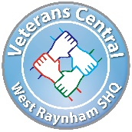
Veterans Central West Raynham SHQ
Annual Activities and Open Day

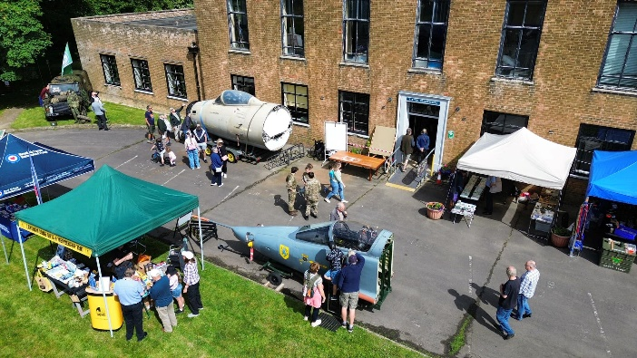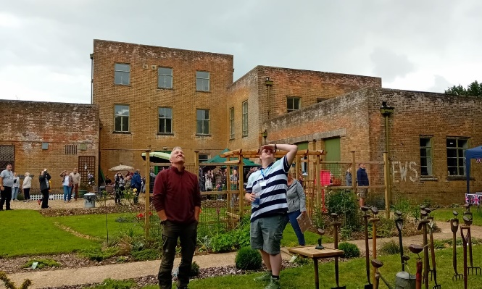

The historic Grade II listed West Raynham SHQ is hosting its Annual Activities and Open Day on 20th July. In addition to viewing this incredible RAF Station Headquarters Building, the day includes:
- Military-related activities:
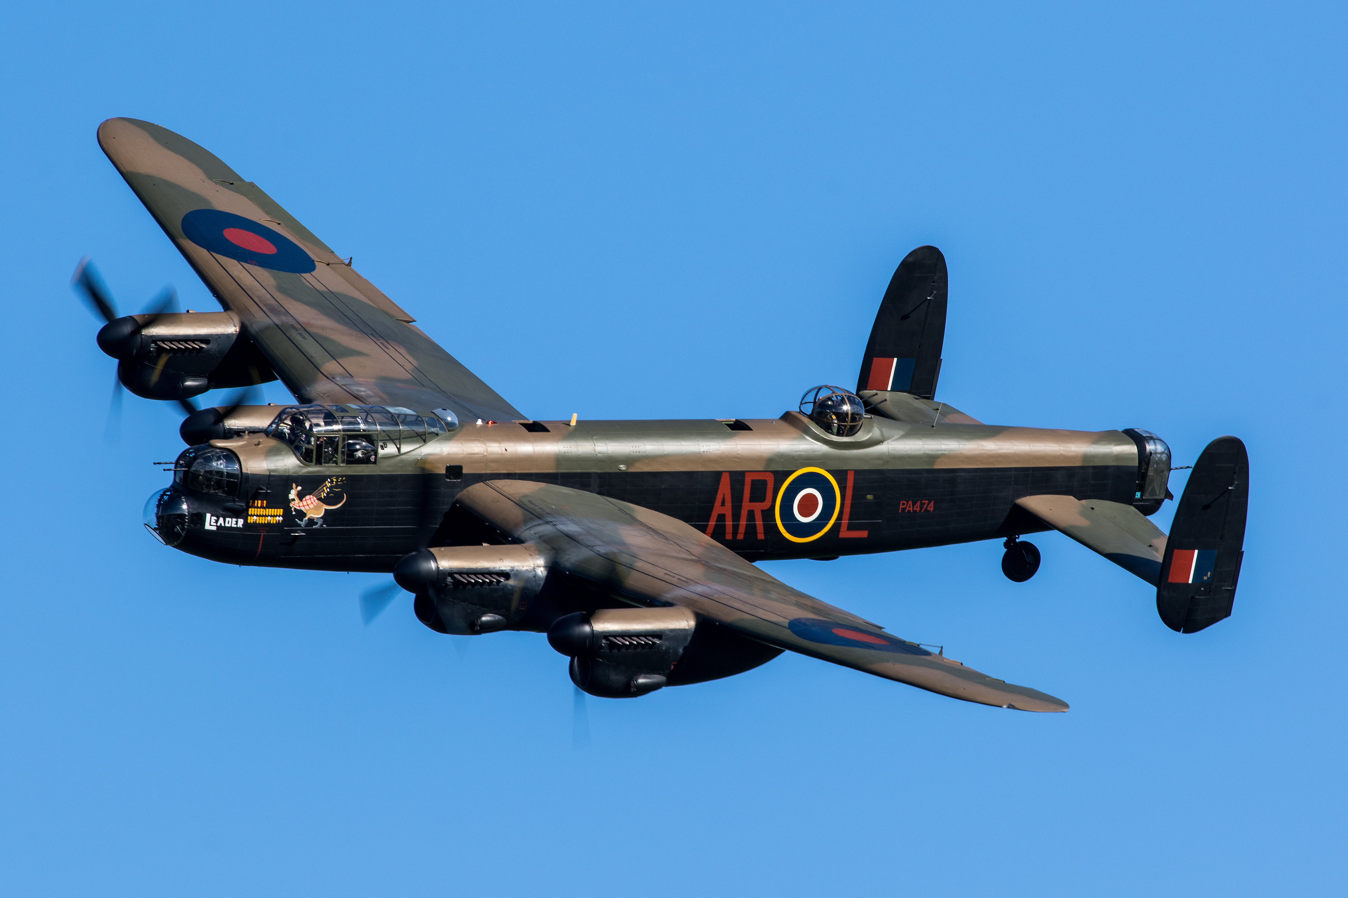
  - RAF Lancaster flypast
  - Hunter aircraft with ‘fighter dispersal’ set-up and open cockpit
  - Canberra PR.9 open cockpit
  - Other aircraft cockpits and displays
  - Military vehicles and Reenactors
  - Bomber Command Virtual Reality (VR) experience
  - Military Memorabilia stalls
  - Military displays including: Royal Observer Corps, Ejection Seats, Jet engines, aircraft and ground armament, air reconnaissance, and more
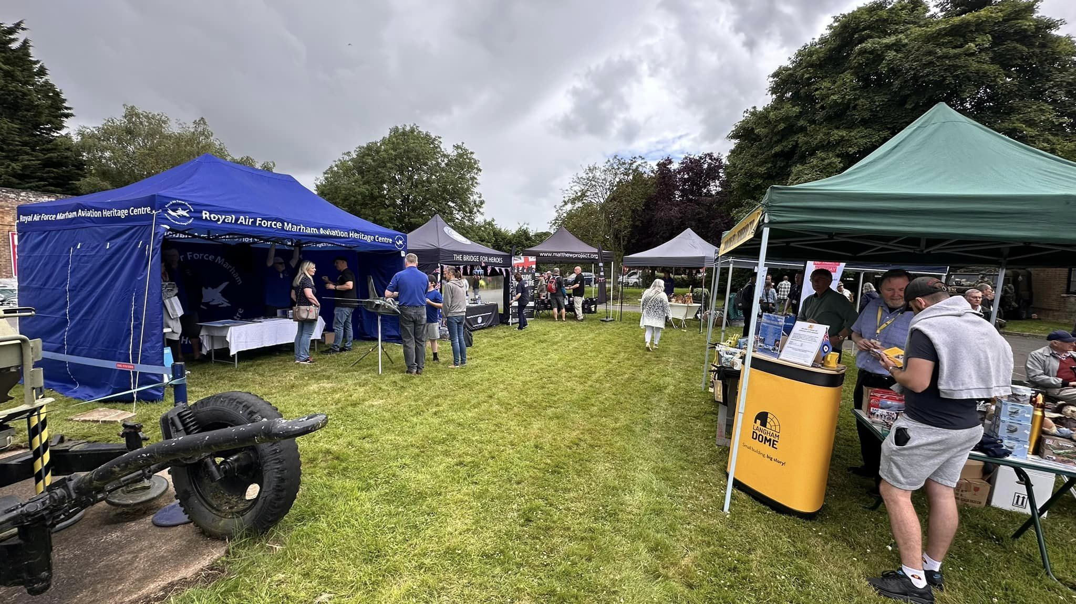
  - Medals display
  - Military Book Sale – hundreds of titles at less than £2!
- Craft and Food/Drink Fair with a range of stalls, plus ‘Thrift Shop’ with clothes and toys
- Children’s Activities:
  - Fun zone, including games, puzzles, storytelling, and more
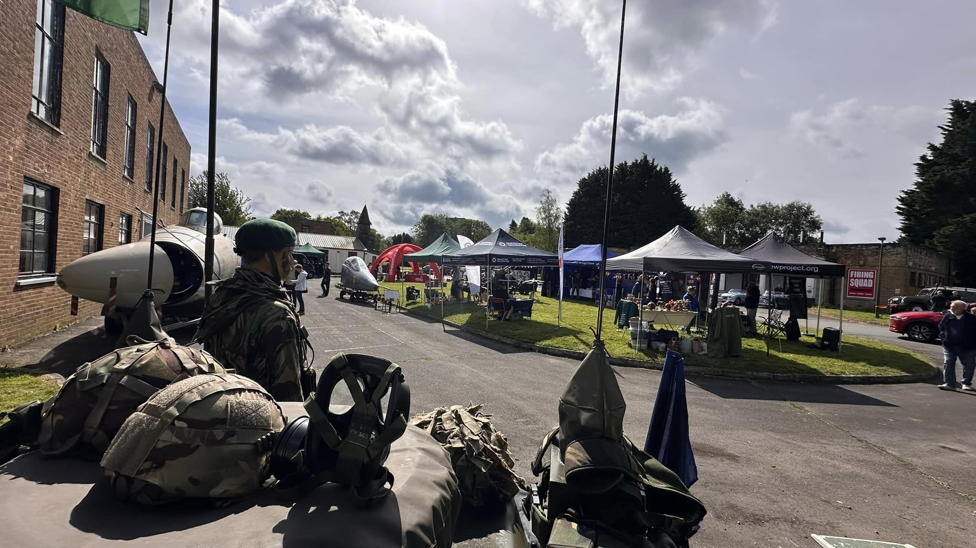
  - Children’s book sale
- Music: Live music with the Swing Tones
- Tombola with over 200 items to win!
- Classic Cars and other vehicles
- Military and Emergency Services charities
- Military and Local History museum displays
- SHQ Gardens
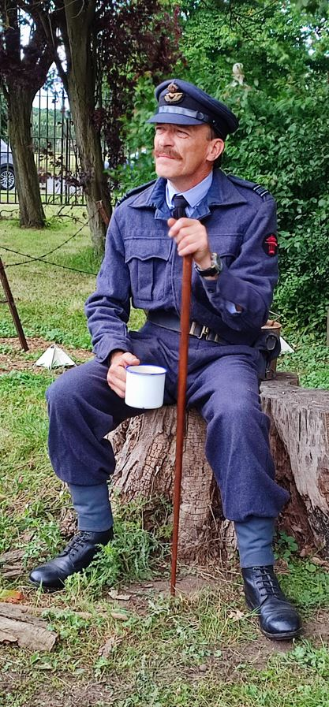
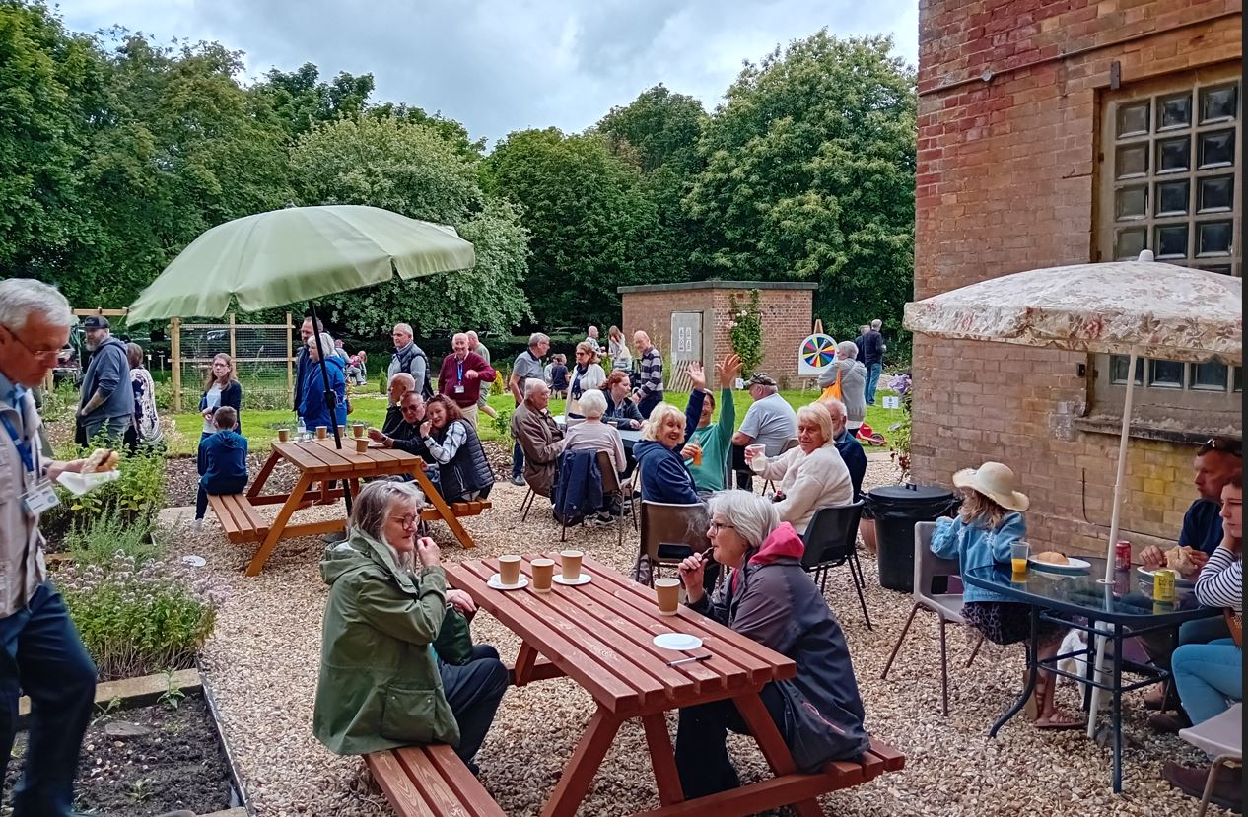
- Food and Drink: SHQ Café (hot and cold drinks and food), BBQ, plus Food Truck
- And more .. the programme is continuing to develop
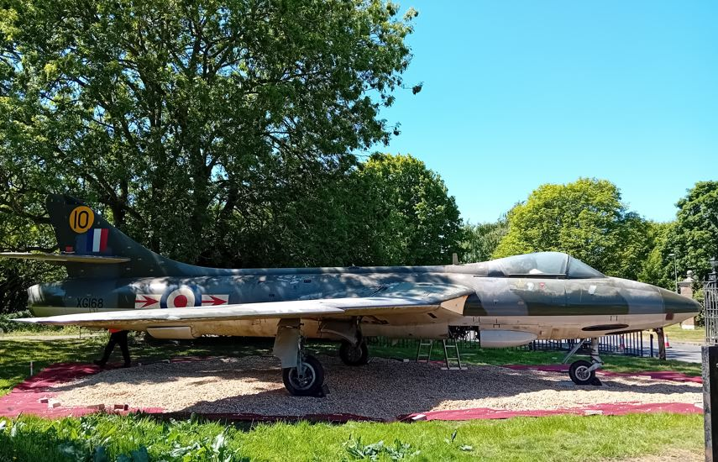
Information: info@veteranscentral.co.uk
 West Raynham SHQ – Veterans Central

Sunday 20th July
1030 to 1500
West Raynham NR21 7PL

