

Patron HM King Charles III

KIPPAX & DISTRICT

Kippax Branch Secretaries AGM Newsletter 2026

RBL Building (The Legion)

With regard to the RBL Kippax roof things are moving slowly, but are nevertheless moving, a Construction engineer has recently visited the site to establish the condition of the roof beams, they have been confirmed as in good condition, and capable of taking the new roof structure. Finance approval is now patiently awaited.

Telecom Mast
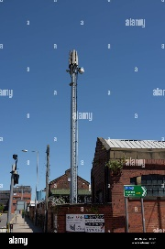
Many of you will be aware that planning was submitted some months ago to erect a Telecom mast on the grassed area, belonging to the RBL, and situated adjacent to Leeds Road. The application failed, upon first submission although there was little or no objections received, Leeds City Planning refused the application on the grounds that it was in the wrong place, however an appeal has now been submitted, again it is a waiting game.

Poetry Competition

This time last year we were busy organising the Remembrance Poetry Competition, which I am sure you remember being very popular and a resounding success, the completed poems were displayed in both St Mary's and the Methodist Churches, the winning poem was read out at the War Memorial on Remembrance Sunday, the Author 7 years of age attended with Parents together with representatives from Great Preston School. A new project within the school for 2026 is the construction of Purple Poppy Wreaths dedicated to Animals lost in World Conflicts.
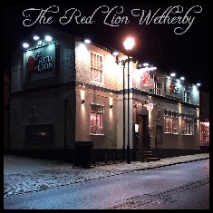
Away Days
At recent meetings, discussion took place that as a Branch we should be getting out and about, as a team, to date members have visited the Red Lion at Wetherby, the HQ of the Wetherby Branch, members then partook of Fish & Chips at the Wetherby Whaler, we received a very warm welcome and a good evening was had by all, we will repeat this during the coming year.

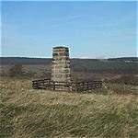
Branch members have recently visited Colsterdale (Brear Banks) the site of the Leeds Pals Memorial for the Somme Memorial, it was a very memorable day, in attendance were the Lord Mayor of Leeds, several dignitaries, a piper, a bugler, six standard Bearers and an array of RBL members including Martin Holman the Leeds Chair.
The eulogy was read by a retired WO1 of the Rifles, which included the thought-provoking statement highlighting the fact that 958 men left Colsterdale Camp on 5th June 1916 for Northern France and the Battle of the Somme, only 47 men eventually returned.

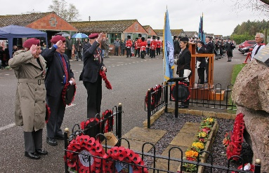
Nine Branch members attended Eden camp on Sunday 13th September, for the Joint Services Memorial. Entry to the event was free to Veterans and Guests, a very memorable day culminating in a Parade, March Past, a Service of dedication, a day which all agreed should be an annual event from the Branch

RBL Cupboard
All the Poppy Appeal merchandise has now been moved from our Poppy Appeal Organiser’s home to the RBL Cupboard. We also discovered a RBL pull up Stand sign which can be used at future events.
The cupboard is now a good space, thanks to members John, Alec, Graham and myself, a special thanks needs to go to Graham for fitting a new light and pull switch, which makes life much easier.
Look Forward

Early discussions have taken place into the possibility of starting a breakfast Club, Graham will outline his thought on the suggestion at the first Branch meeting after our AGM. The Stewards and staff at the Legion Club are enthusiastic, however it needs full discussion at Branch Committee discussion and approval to be planned.

Discussion has also taken place relating to the suggestion of arranging an afternoon tea event in early December, further suggestions have been made that it could possible be considered as a 40s event, with music of that period, with an opportunity for people to dance, to be discussed.

Steve Bottom (Branch Secretary)

