
Embroidered in gold wire on a black background, this blazer badge features the lion member's badge of The Royal British Legion.
A navy tie with single Standard Bearer's motif
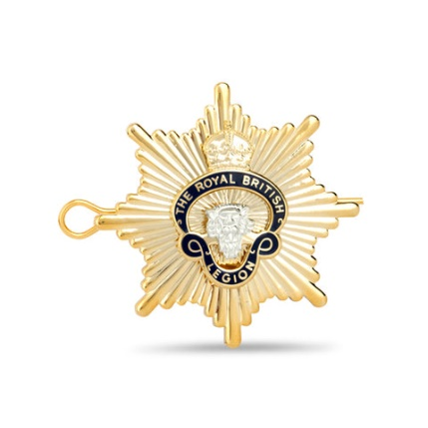
Beret badge from The Royal British Legion
A navy blue tie with multiple Royal British Legion lion badge motifs embroidered on it
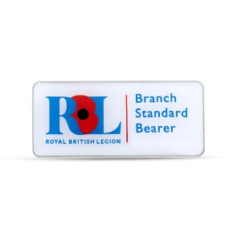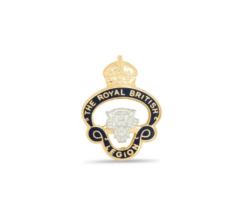
MEMBERS Branch Standard Bearer Badge
Members Badge enamelled with The Royal British Legion lion design.

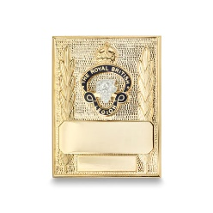A gold coloured metal badge with Legion lion badge design and space for engraving, suitable for attaching to a Standard Bearer's sling.

