CHELSEA PENSIONERS VETERANS’ OUTREACH

“Helping Older Veterans Live a Better Life Longer”

A VISION FOR OUTREACH

“As a veteran of campaigns in Northern Ireland, The Balkans, The Gulf, and latterly two prolonged and very demanding wars in Afghanistan and Iraq, I have seen many comrades leave the Services carrying injuries both mental and physical that will be with them in some form for life. When interviewed by the Commissioners for the post of Governor I therefore stated that if I got the job I would not only do my utmost to ensure that the 300 or so In-Pensioners continue to be cared for to the highest standards, and to preserve our glorious buildings for them and for the Nation, but that I would seek to leverage the influence and reputation of the Royal Hospital Chelsea to provide more direct support to Veterans, particularly the elderly, living outside our Chelsea home. The Soane Stable Block development provides the perfect venue for the initial phases of this work. Thank you to all who help us with this vital project.”
General Sir Adrian Bradshaw KCB OBE CB - Governor

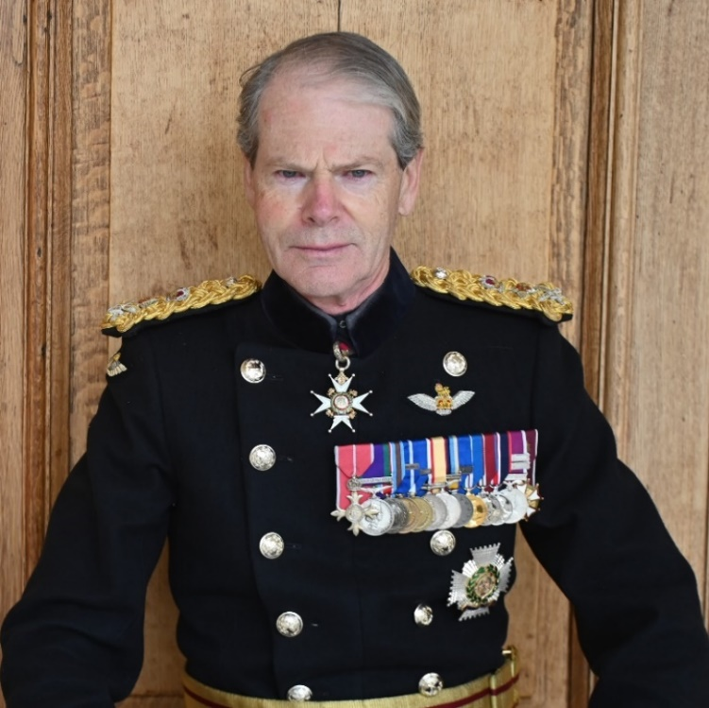

A LONG HISTORY OF OUTREACH

Origins
King Charles II ordered the building of a retirement home for old soldiers in 1682 and the Royal Hospital admitted its first Army Veterans in 1692; Our history of outreach is almost as old.

At a time when the Nation was constantly engaged in war, wounded and discharged soldiers were billeted to Chelsea and across London, or furloughed to neighbouring counties, while they waited to be admitted to the Royal Hospital. These ‘Out-Pensioners’ were paid pensions by the Royal Hospital from the 1690s up until 1955.

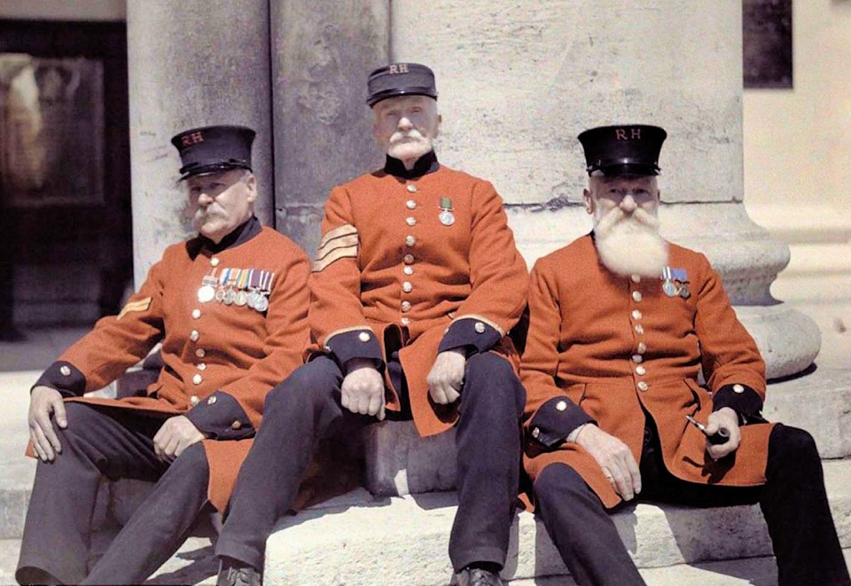

After 1955, the administration of pensions was no longer the responsibility of the Royal Hospital’s Commissioners and only ‘In-Pensioners’ received their support. Veterans living in wider society have had to rely on the Veteran’s Agency, the NHS, the Department for Work & Pensions and local authorities. However, although the Royal Hospital’s focus narrowed to residents of the historic site, our mandate for care was, and remains, wider.

The Next Chapter
The Royal Hospital Chelsea is now seeking to reconnect with a new generation of ‘Out-Pensioners’. We intend to establish social links and activities with many of the older Veterans, from all three Services, who may not have had the opportunity or have preferred not to become In-Pensioners, but who nevertheless would welcome the opportunity to spend time with each other and with In-Pensioners. Together, enjoying social life, activities and care programs, they will also benefit from the special care, comradeship and sense of community fostered here at the Royal Hospital Chelsea.

Our Outreach project seeks initially to invite older Veterans from the local area and within an easy train or bus ride of the Royal Hospital to come and enjoy time with In-Pensioners in the new facilities provided in the re-furbished Soane Stable Block. They will take part in hobbies and activities in our new Prince Philip Building and enjoy the heritage the British Army in the British Army Museum and the historical and architectural delights of the Royal Hospital Chelsea. In doing so not only will we provide them with the benefits to mental health and wellbeing well-known to be derived from social interaction, but we will also be able to connect them to charities and other bodies to help them with needs that might become evident during their time and interaction with us. The Royal Hospital Veterans’ Outreach team will provide help and advice, and the contact details of numerous other organisations who can provide support to Veterans, especially through the close links and collaboration we have established with our Service charity partners.

THE CONTEXT

Our comprehensive active ageing programme here at the Royal Hospital Chelsea encourages Chelsea Pensioners to support each other, just as they did during their Army service. This includes spending time together socially, accompanying each other on visits and activities, going with fellow In-Pensioners to external medical appointments, and visiting comrades in hospital. Veterans together, with their shared experience of the Service ethos and of the rigours of military campaigns, can be of enormous help to each other, leveraging the bonds between Veterans that go beyond the spoken word. This can be of significant benefit to their mental health and wellbeing, particularly in dealing with the effects of PTSD. Chelsea Pensioners also work together to support the routine and services of the Royal Hospital and contribute to the community to which they belong.

The Royal Hospital is immensely grateful for the annual Ministry of Defence funding that meets about half of the cost of providing services to our resident Chelsea Pensioners and maintaining our buildings. But now, by providing our unique brand of comradeship, care and sense of community, we want to help not only the 300 or so fortunate and deserving In-Pensioners pensioners living here, but also many from amongst the 1.85 million (ONS Census 2021) who identify as Veterans from all three Armed Services living beyond our gates.

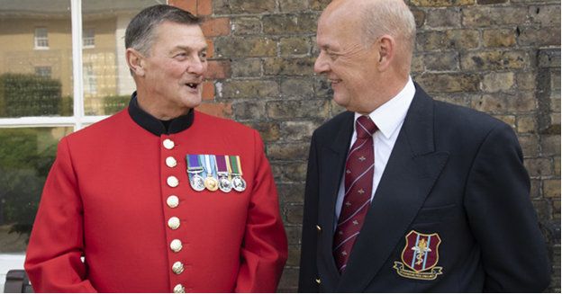

THE NEED FOR CONNECTION AND SUPPORT

Comradeship helps armies to succeed in battle. The shared ethos and sense of belonging of Soldiers, Sailors and Aviators contributes to the ‘Moral Component’ of the fighting power of our Armed Services, fuelling and sustaining their will to engage in combat.

When they leave the Army, soldiers no longer live, work and serve alongside their comrades. This can leave a void, particularly for those who have been wounded physically or mentally, that is not always recognised or understood. Acute feelings of isolation can follow.

Society’s growing concern about loneliness and its impact is widely documented. Regrettably, it has become widespread among older people in the civilian population. Older veterans are at increased risk of loneliness due to declining health, retirement, and instability of social ties, along with a stigma around seeking help, related to aspects of the perceived military culture of ‘self-reliance’.
In addition, 18% of veterans over the age of 65 also undertake unpaid caregiving responsibilities, compared to only 14% of their civilian counterparts. Research shows the effect caring for someone else can have on the mental health of the carer: 15% of veteran carers aged between 75-84 years said that they struggled to cope with care responsibilities. Several ex-Service personnel are also likely to receive regular care themselves. We aim to reach both groups through our Outreach programs.

OUR VISION FOR DELIVERING VETERAN’S OUTREACH

Chelsea Outreach
Chelsea Outreach operates from new facilities here at the Royal Hospital, including the purpose-built Activities Centre and adjacent Soane Stable Yard. We hold 2 x weekly Drop In sessions supported by our Delivery Partners and offer activity groups, talks, demonstrations and refreshments for local Veterans The Royal Hospital’s extensive grounds and gardens will provide the health and wellbeing benefits of urban green spaces. The programme provides comradeship and a sense of community to Veterans of the three Armed Services, focused on those of pensionable age, who might benefit from the company of other Veterans who have lived the Service ethos and experienced the unique challenges of military campaigning and war.

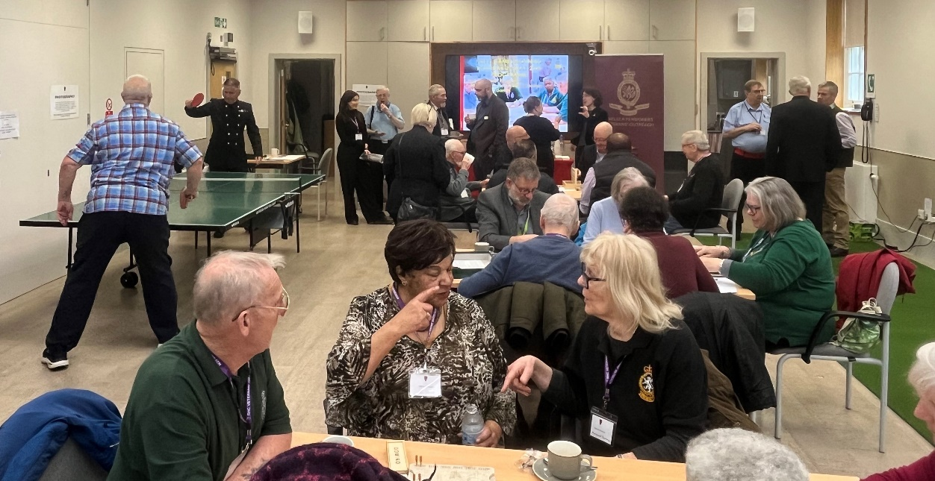

Nationwide Outreach
This element of the programme seeks to connect with older Veterans who are living too far from London to be able practicably to regularly join our activities at the RHC. Through collaboration with local service charities, local authorities and other veteran focused organisations in the Regions we aim to connect with Veterans through events and activities close to where they live, particularly targeting any veterans who are isolated or lonely. This idea will be piloted in the Southeast region starting in April 2025.

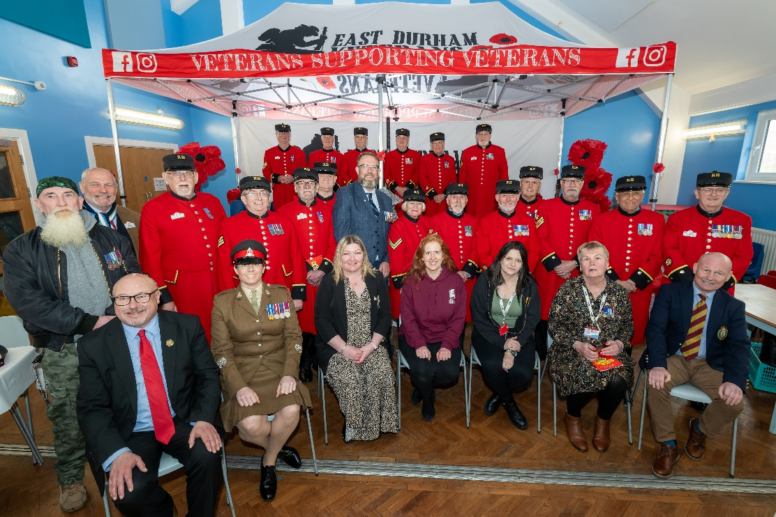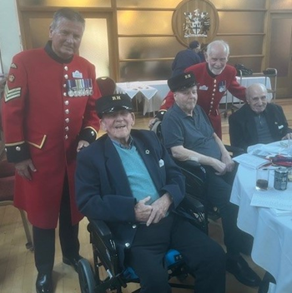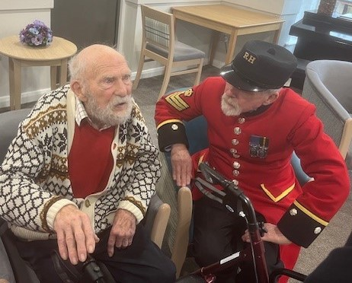

Digital Outreach
Digital Outreach will continue providing an expanded virtual ‘community of comradeship’ for older veterans, providing digital meetings and pairing non-resident ex-Service personnel with Chelsea Pensioners. Using a user friendly digital platform, we will extend an important lifeline to those who are socially isolated and build an online community of veterans connected to the Royal Hospital and our In -Pensioner Volunteers.

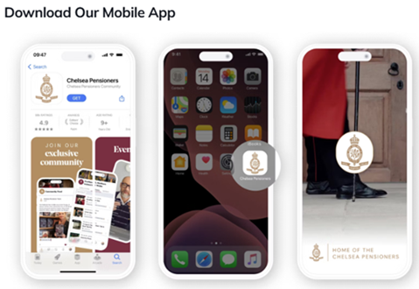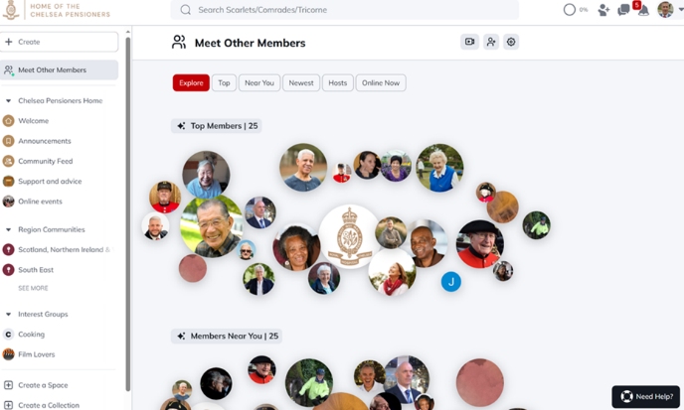

Carer’s Outreach
Carers Outreach is our aspiration to provide help and advice for carers of Veterans and to Veterans who are carers. Initially the programme will focus on identifying the needs of carers and connecting them with charities and local authorities to develop referral pathways for those most in need. We may subsequently develop facilities here at the Royal Hospital in which Veterans could be looked after for short periods by qualified suitably qualified staff, in order to give the respite to their own carers who desperately need it.

GOVERNANCE AND LEADERSHIP

The Royal Hospital Chelsea Outreach Program was launched under the strategic direction of the Commissioners, appointed by Her Majesty the Queen to oversee the management and direction of the Royal Hospital. The Outreach Strategy is directed by the Royal Hospital Chelsea Executive Board under the leadership of our Chief Executive David Richmond. A Director of Veterans’ Outreach – Giles Woodhouse has been appointed to develop strategy and growth and to lead the Digital elements with the Head of Veteran Outreach, Jonny Lowe responsible for physical delivery of the programme both on and off site.

The Chelsea Pensioners Veterans’ Outreach Staff Team comprises of a Veterans Outreach Officer, Greta Kendall with Sarah McPhee providing administrative support. Additional staff to support the Regional and Digital elements of the programme have been appointed and will join the team in April 2025 The programme continues to rely upon support from, external volunteers recruited specifically for the programme, and most importantly In Pensioners themselves who are the lifeblood of the programme.

REACHING ALL THREE SERVICES
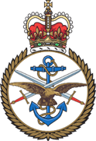

For the first time in our long history the Royal Hospital Chelsea will begin actively to support, through the programme, those who have served not only in the Army but also in the Royal Navy and Royal Air Force. We have discussed this expansion of our remit at top levels with the Service charities and our aspirations have been warmly welcomed. We much look forward to working with a range of military charities in delivering our Outreach programmes.

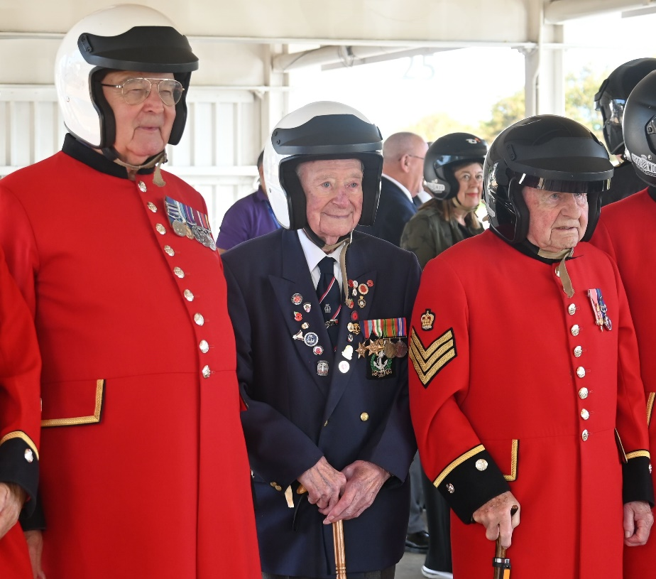
CONCLUSION

Our founder’s vision – to provide for Veterans who had so loyally served him and deserved the best possible care – remains as fresh today as it ever was. We believe that the comradeship and support programmes we are now developing to serve the wider Veteran community expresses that vision with renewed vigour in the 21st Century.
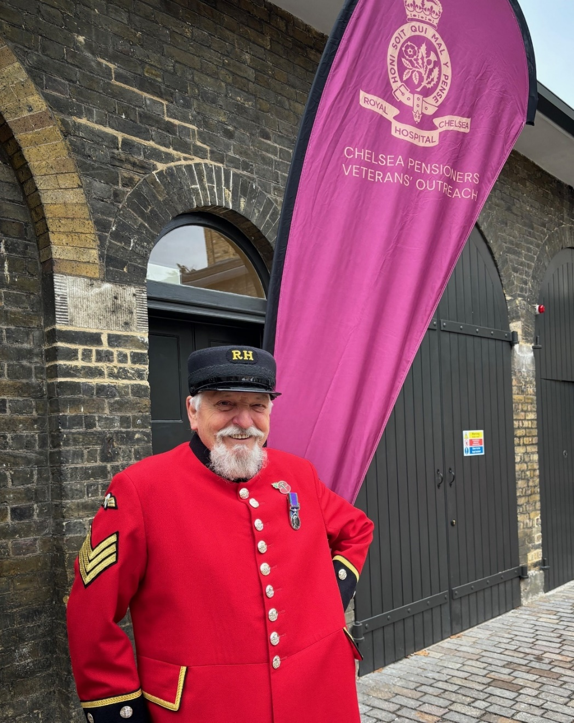

VeteransOutreach @Chelsea-Pensioners.org.uk

