1st October 2024 Jason Coward RBL's National Chair – Announces new National President

I am pleased to welcome Vice Admiral (Rtd) Paul Bennett CB OBE to the RBL as our next National President. We know he is a passionate advocate for those who serve and have served and will bring his insights and significant experience to our work during his term. He joins us ahead of this year’s Remembrance period to represent the RBL at this year's Remembrance events and beyond, and we very much look forward to working with him in his new role.

His first duties as National President will be to represent the RBL at key ceremonial events, including the National Service of Remembrance at the Cenotaph and our Festival of Remembrance in November.

The First Sea Lord, Admiral Sir Ben Key KCB CBE ADC, said: “I am delighted that Vice Admiral Paul Bennett has been appointed as National President of the Royal British Legion. Paul had an exemplary career in the Royal Navy, culminating in roles of Commander of the UK Maritime Forces, and Chief of Staff of NATO Allied Command Transformation. Positions requiring significant oversight and leadership to deliver complex outputs across multiple organisational domains. I am sure that his experience and passion will be hugely valuable in his position as RBL National President.”

Vice Admiral Bennett joined the Royal Navy in 1985 and enjoyed an extensive career at sea, including several roles ashore. He was recognised with an OBE for his work as a Capability Manager in Navy Command for Above Water Capability and Maritime Security. His final role before retiring from services in 2021 was as Chief of Staff for Allied Command Transformation in Norfolk, Virginia, after which he took up role as a NATO Senior Mentor.

Vice Admiral Bennett’s appointment follows the passing of Sir Clive Johnstone KBE CB who held the role from May 2023 until May 2024.

Vice Admiral Bennett’s appointment follows the passing of Sir Clive Johnstone KBE CB who held the role from May 2023 until May 2024.

Jason Coward, National Chairman

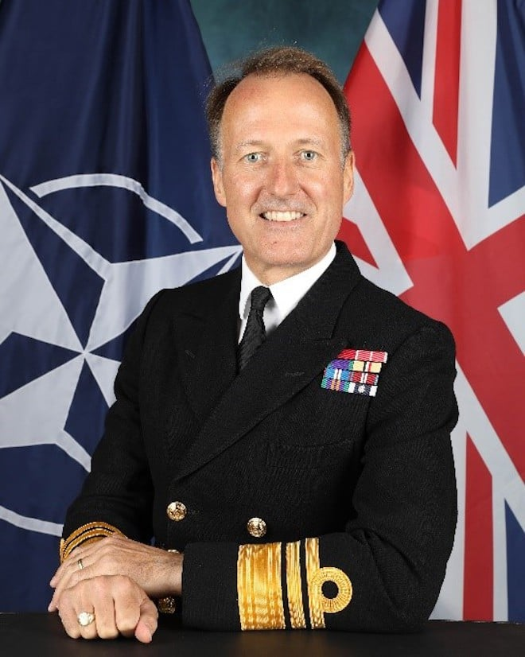

Vice Admiral (Rtd) Paul Bennett CB OBE appointed as the RBL National President. 1st October 2024.

