THE ROYAL

BRITISH LEGION

WOMEN’S SECTION

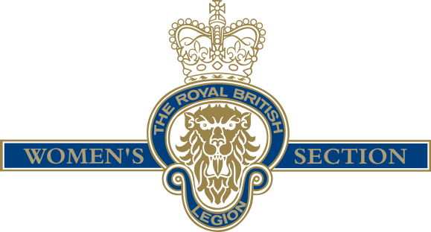

MOTIONS 2022

Results to be given at the Virtual AGM 22th January 2022

Details on how to vote will be released ?

**Motion 1**

**Branch Name:** Central Committee

**Proposal:** To permit the Grants Team to continue with the ability to consider and approve Exceptional Grants on cases that have an identified need that falls outside of the Women’s Section Fund’s main categories for assistance. Grant officers would identify cases and raise them to the Grants Manager and Head of Grants & Social Policy to consider an Exceptional Grant.

**Process:** The same process as last year would be used whereby any Exceptional Case would be reviewed by two levels of Management, in line with TRBL’s own policies and guidelines. There would also be records kept of any Exceptional Grant approvals to detail the Grant category, approved amount, any direct impact and reasoning for the approval – this will allow us to collect data whilst mapping the needs and make it possible to generate accurate reports to feedback to the Central Committee.

**Duration:** We would propose this to be for a further 12-month period.

**The Main Reasoning:** This would allow the TRBLWS Welfare Fund to continue to support the most Vulnerable Children in urgent/crisis instances effectively.

**Effect if passed:** a) Maintain an improved turnaround time for Exceptional Grant case decisions and fund administration to other case working organisations. .

b) Give us 2 years of data to quantify any improvements, both during and after lockdowns, to establish if there are longer benefits to this way of working.

**Proposed**: Sandra Saban

**Seconded**: Horley Branch

**Motion 2**

**Branch Name:** Chatteris

**Proposal:** Standard Bearers to be allowed to wear trousers.

**Reason for Inclusion:** When carrying Standards for the Women’s Section to be given the same choice of wear i.e skirts or trousers as women carrying Branch Standards.

**Effect if Passed:** A feeling of equality with Branches.

**The Main Argument:** Women carrying Women’s Section Standards are not given the same choice as Women carrying Branch Standards. Same rules to apply to both the Branch Standards and the Women’s Section Standard Bearers “we want to be treated the same”.

**Proposed**: Janice Baynes, Chairman

**Seconded**: St Ives (Hunts) WS Branch