**ROYAL BRITISH LEGION WILTSHIRE COUNTY NEWSLETTER**

**AUGUST 2019**

**COUNTY NEWS**

**County Vice Chairman’s Departure**

Mike Challinor has now officially left his County duties as County Vice Chairman and will be departing for pastures new in Shropshire in August. We would like to thank Mike and his wife Priscilla for their dedication and hard work for all of the branches and Wiltshire County over the years. A leaving presentation and buffet was held for Mike and Priscilla in the Swindon Area Office and an evening meal in Devizes with the County Executive Committee Members. A huge thank you to all of the branches who sent messages and contributions for presents and the leaving card which were greatly appreciated by both Mike & Priscilla.

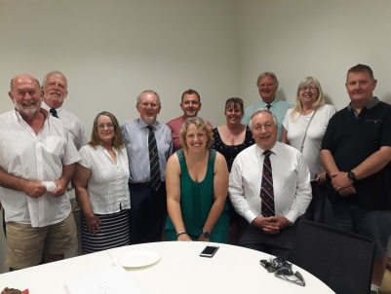 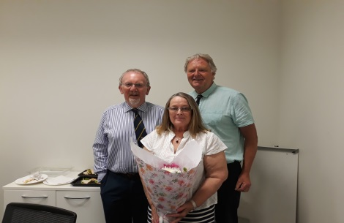 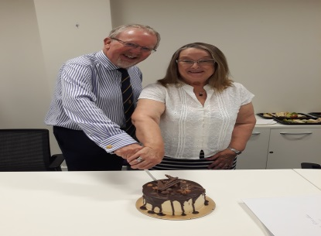

**New County Vice Chairman**



I am pleased to inform you that a new County Vice Chairman John Mann was appointed at the CCEX Meeting on the 23rd July 2019.

Squadron Leader John Mann MBE RAF (Retd) a current member of the CCEX and President of the Potterne Branch has kindly agreed to take up the position for Wiltshire and is very much looking forward to working with all the branches and CCEX Committee as the County Vice Chairman.

John says, “It is a great privilege to have been elected by the CCEX Vice-Chairman of the Wiltshire County Executive, and I shall do my very best to support the Chairman and the rest of the Committee as I take over from Mike Challinor, who has been a most excellent Vice-Chairman and to whom I have expressed my very best wishes for his new life in Shropshire. It is my intention to assist branches as much as possible, especially in the areas of recruitment, training and member retention, and I would be happy to hear members’ ideas and suggestions for improvement in these important areas – or any other relevant matters. Please do not hesitate to email me with your thoughts.”

**Squadron Leader John Mann MBE BSc RAF (Retd)**

John Mann (66) was born and brought up in Kent, progressing from school in Canterbury to attaining an honours degree in Applied Physics at University College London (UCL). Interested from an early age in flying, John joined the University of London Air Squadron as a member of the RAF Volunteer Reserve, flying Chipmunks and Bulldogs; he was later awarded an RAF University Cadetship and went directly from university to the Royal Air Force College, Cranwell for Officer Training, followed by Pilot Training on the Jet Provost, Gnat, Hunter, and Canberra. John’s operational tours were on the Vulcan bomber, first as a co-pilot on IX(B) Squadron at RAF Waddington, then as a captain on 27 Sqn, RAF Scampton. The Vulcan’s end-of-life in 1982 led to John’s re-training as a Qualified Flying Instructor (QFI), in which role he served on East Midlands Universities Air Squadron and on loan as an advisor to the Royal Jordanian Air Force. Returning from Jordan in 1987, John spent a tour training flying instructors at the RAF’s Central Flying School before being appointed Officer Commanding the University of Birmingham Air Squadron at RAF Cosford, after which he was honoured by being awarded an MBE. John’s final tour before his retirement from the RAF in 1992 was at the Ministry of Defence in London, with responsibility for primary and basic flying training.

On leaving the RAF, John and his wife, Christine, entered the world of business, initially running their own Design and Marketing Company which led to various other roles in property development and management. Success in the fields of marketing and IT led to John becoming a director of a small distribution firm, followed by ten years as managing director of a large manufacturing and distribution company. Approaching retirement, John and Christine founded their own company in the field of GPS and Satellite Navigation, producing a much-needed digital map of Barbados.

Retiring from full-time work in 2014, John and Christine moved to Potterne, Wiltshire, where John joined the Royal British Legion and started to take a full and active role in community life. In 2018, John was honoured to be elected President of the Potterne branch of the RBL, in which he takes a most active role, and was also accepted as a member of the RBL’s Wiltshire Executive Committee. John also helps organise the Potterne church fete, and last year took a major part in local events in remembrance of the Armistice Centenary.

**Branch Account Submissions**

It is that time of year again – all branches need to submit their accounts for the year end by the 31st September. You do not need to wait for your AGM to take place to submit your accounts. Please ensure that you contact me prior to the deadline if you are having any issues in submitting your accounts.

I have also arranged with our RBL Independent Examiner Anne Bevis to hold Open Days on the dates below where you can pop in your completed accounts, come in with any questions, and have your accounts IE by Anne or any other general enquiries:

Please member to bring all your receipts, paying in books, chequebooks stubs and any other account receipts with you if you would like Anne to IE your accounts.

Myself and Anne will be at the following locations from 11:00 – 3pm on the dates below:

* 13th August – Swindon Area Office, 52 – 54 Regent Street, Swindon, Wiltshire, SN1 1JS
* 14th August – The Red Lion, Salisbury, Churchill Suite, Milford Street, Salisbury, SP1 2AN
* 3rd September - Swindon Area Office, 52 – 54 Regent Street, Swindon, Wiltshire, SN1 1JS
* 27th September  - The Red Lion, Salisbury, Churchill Suite, Milford Street, Salisbury, SP1 2AN

**Post Correspondence**

Please ensure that any items / correspondence posted to me are marked for my attention to the County Office at Swindon, 52 – 54 Regent Street, Swindon, Wiltshire, SN1 1JS or direct to my email on [fhedges@britishlegion,org.uk](mailto:fhedges@britishlegion,org.uk).

**Details of Branch Remembrance Services 2019**

This year is proving to be a very busy year all round - Please can all branches forward me details of any planned Remembrance Services or Events as soon as possible. Details will be put on the County Website and Facebook Pages.

**Festival of Remembrance – Albert Hall & Cenotaph**

**Membership Ticketing**

The Royal British Legion Festival of Remembrance will be held in the Royal Albert Hall, London on Saturday 9 November 2019 with performances at 2.00pm and 7.00pm. Members will be able to buy tickets on a first-come-first-served basis, in an exclusive Member sale, buying tickets directly from the ticket agent.

**Requirements**

In addition to the implementation of GDPR, the Metropolitan Police have asked for the following information for all guests that will be attending the Festival of Remembrance, both afternoon and evening performances:

o Full Name (this must be exactly as it appears on your photo ID)

o Address (please include post code)

o Date of Birth (please use the format DD/MM/YYYY)

o Email address

o Contact number

This information will be allocated to seat numbers and all tickets must be individually named. The ticket agent has agreed to gather all the data on behalf of the Legion and will be GDPR compliant. The ticket seller will share the data with TRBL and Met Police only. All data will be deleted within one month after the event.

**Improvements from 2018**

The following improvements have been implemented based on membership feedback.

An online seat picker which will allow members to choose seats next to others they may know.

More call centre staff will be available during ticket launch week. This will decrease wait times

on the phone that were present in 2018.

A staggered launch for afternoon and evening tickets. This will help ease pressure on call

centre staff.

A better process is now in place for re-prints and last-minute name changes – this was

identified as a problem in the two weeks running up to the Festival.

Each member will now be able to book up to 4 tickets for the afternoon performance. Evening

will remain as 2 tickets per member.

**The process for purchasing tickets for the Festival of Remembrance is as follows:**

**Thurs 1 Aug: Evening tickets go on sale**

All members of the Legion (including the Women’s Section) can purchase up to 2 tickets from 10.00am for the Evening Performance by phone or online.

**Thurs 8 Aug: Afternoon tickets go on sale**

All members of the Legion (including the Women’s Section) can purchase up to 4 tickets from 10.00am for the Afternoon Performance by phone or online.

The phone lines may be busy on both days (1st and 8th August) so I would advise to use the online seat picker to book tickets.

Members can buy tickets online via <https://festivalofremembrance.seetickets.com> or by phone 020 7087 7929. This link will not be live until 1st August.

Each member must be prepared to quote the name of their branch and membership number when booking, as well as the information requested by the Metropolitan Police below for each guest to process the ticket booking:

Full Name (this must be exactly as it appears on your photo ID)

Address (please include post code)

Date of Birth (please use the format DD/MM/YYYY)

Email address

Contact number

Payment will be taken at the time of booking. Postal applications will not be accepted. Tickets will be issued on a first-come, first-served basis. No tickets will be issued before full ticket holder details are received. Tickets will be posted directly to the lead ticket booker in October. Once confirmed tickets sent are non-returnable or refundable. You are able to change the name of your guest before 1 October by calling the ticket agent. All membership numbers will be checked. A clause will be written into the purchaser terms and conditions that a refund will be processed if an invalid / fraudulent membership number is used.

**Fri 6** Sep All membership numbers checked for validity by TRBL. Invalid numbers are contacted and tickets will be refunded.

**Mon 16 Sep** Refunded tickets go on resale (if applicable)

**Mon 30 Sep** Ticket sales open to the general public.

**Sun 13** Oct All ticketing closes. Tickets are posted to the lead booker.

**Ticket prices**

Ticket prices for both the afternoon and evening in 2019 (including VAT) are:

Grand Tier Boxes (afternoon performance only) £30.00 per seat

Loggia Boxes (afternoon performance only) £30.00 per seat

Second Tier Boxes £25.00 per seat

Stalls £25.00 per seat

Circle (Centre) £10.00 per seat

Circle (Restricted View) £10.00 per seat

Wheelchair spaces £10.00 per seat

There will be a nominal charge of £1.75 per order to cover delivery costs.

Carers accompanying a wheelchair space occupant will also be charged £10.00 for their seat.

**Security**

Due to heightened security measures the Metropolitan Police will need to conduct individual security checks on all participants. Basic personal information will need to be provided in advance for each applicant. Ticket holders will need to bring with them both photographic ID and a document showing proof of Membership (where applicable) for access to the Royal Albert Hall via manned Police entry points on the day.

Dress - Members of the Legion attending either performance of the Festival of Remembrance are requested

to wear the Legion badge, tie and decorations.

**CENOTAPH CEREMONY**

The annual National Service of Remembrance will be held at the Cenotaph in Whitehall on Sunday 10 November. The Royal British Legion organises the annual Veteran March Past that passes the Cenotaph on

Remembrance Sunday for 10,000 British and Commonwealth former military and civilian Service personnel.

Participants must meet at least one of the following criteria:

Military or civilian men and women from the UK and the Commonwealth who served the

Crown on Military Operations

Wives, husbands or civil partners of veterans who died as a result of their service in Her

Majesty’s Armed Forces

A carer of a veteran requiring wheelchair assistance

Members of The Royal British Legion who meet the eligibility criteria are encouraged to march with

their relevant Corps, Regimental or Service Association.

Members who meet the eligibility criteria and wish to march as part of The Royal British Legion

contingent, should contact their Membership Support Officer before the 11th August.

**County Poppy Appeal Launch & News**

Poppy Appeal Launch

Wiltshire Poppy Appeal Launch will be taking place on Friday 25th October, Bowood House.

Poppy Appeal Totals to date

NATIONAL £50.55M PLUS 5.67%

SOUTH £ 7.02M “ 7.31%

WILTSHIRE £796,100k “ 6.68%

The County looks set to achieve a total of over £800,000 before the year end in September. An incredible record total, Fi Dobson would like to thank all the PAO’s for their hard work and commitment.

**National Armed Forces Day**

The National Armed Forces Day was held on the 28th, 29th & 30th June and was a great success and a credit to Wiltshire. I would like to extend a thank you to our Parade Marshal John Smith and all the Standard Bearers who attended over the weekend for both the parade and Drumhead Service. Their hard work and commitment shown by battling the heat and crowds on the days was a credit to Wiltshire. I would also like to thank all the branches who attended and supported this event and hopefully had a great day. Marlborough Branch took a coach full of people for a great day. Thank you also to the Operations Team, Volunteers, Marketing Team and Veterans Gateway Team who supported me manning the RBL Marque over the weekend as well as marshalling for the Human Poppy Attempt and raised over 1.5k for the Wiltshire Poppy Appeal. Below are some photos of the weekend:

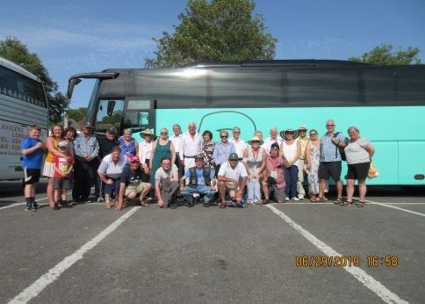 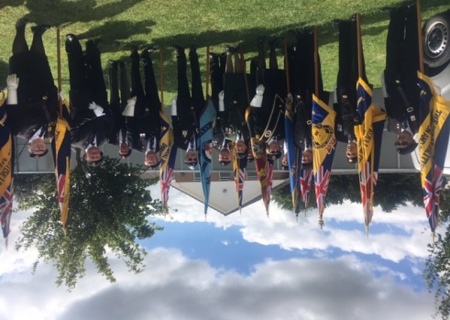 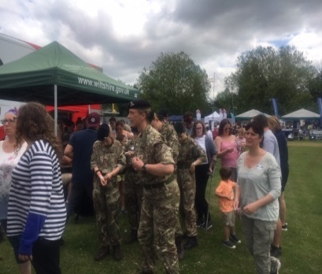

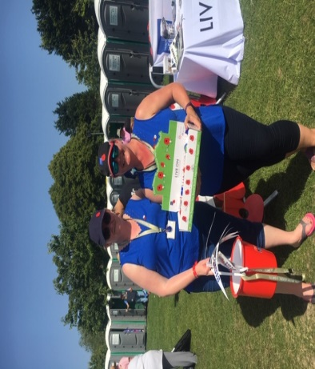 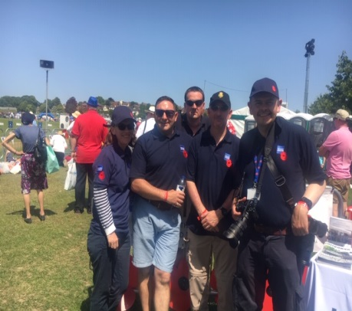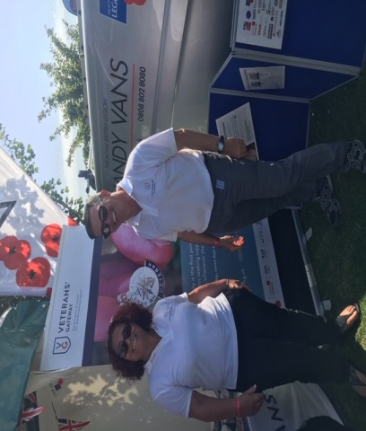

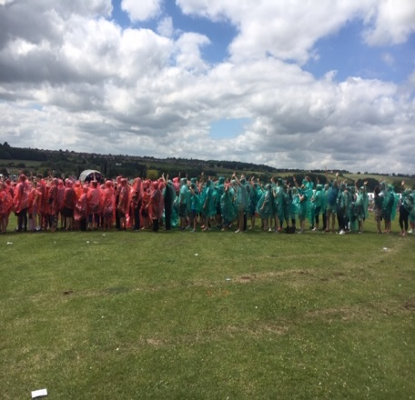 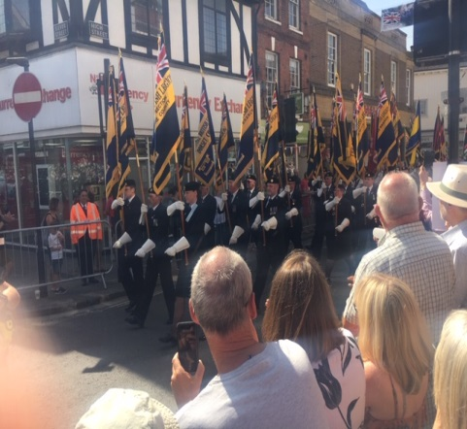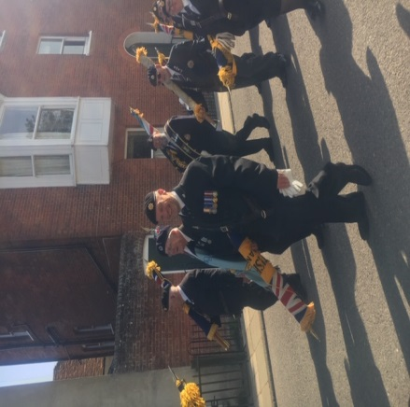

**We will Remember Them Concert - D-Day plus 75 & The Roaring Forties - Sunday, 3rd November 2019 at 3p.m, Salisbury**

The annual concert to raise money for the RBL Poppy Appeal is being organised by Brain Easterbrook and his team. Please support this annual event which is a marvellous evening of entertainment as well as for a good cause. This will be the twentieth remembrance concert of its kind in the Salisbury City Hall and it is believed that you will not want to miss this special annual event which has become increasingly popular with Salisbury residents.

Concert Details below:

D-Day plus 75 & the Roaring Forties, is a concert to celebrate the success of D-Day 6th June, 1944 and to remember the brave men and women of our allied forces who, on that day in history, made the ultimate sacrifice that we may enjoy peace in our time. So, who better to help us celebrate and remember than the D-Day Darlings, Britain’s Got Talent Finalists 2018, and currently riding high in the music charts with their CD, “I’ll Remember You”. They will be supported in the first half by the Hyde Band who have a reputation for delivering Glenn Miller music dressed in American GI uniforms and in the style of a 1940s big band – they will be enhanced by the 40s dance troupe “Braces and Lace”. You are invited to embrace the 40s theme by dressing in the fashion and hair styles of the period! Salisbury Royal British Legion Band will open the second half with music to remind us of the role played by the R.B.L. since its inception in May, 1921 to provide support for our ex-servicemen and women of the combined arm forces. The show will conclude with a Service of Remembrance, Last Post & Reveille and the singing of “Land of Hope and Glory”.

Tickets can be booked via the box office on 01722 434434 – booking early is advised.

**Wiltshire County Annual Conference 2020**

The Wiltshire County Annual Conference 2020 will take place in Warminster Civic Centre on Saturday the 8th February 2010. Please keep the date in your diaries and further information will be sent out later in the year as usual.

**Standard Bearer News**

Please find below the confirmation of the Training Dates  - these are held at The Cotswold Centre, Neston , SN13 9TU.

August 18th 2019

September 15th 2019

October 20th 2019

November 17th 2019

December 8th 2019   - Cathy and John would like to arrange a social get together on this date – please let her know if you would like to attend this.

**Please note the SB Competition Date has been changed to the date below:**

21st September 2019 at the Cotswold Centre , Neston, SN13 9TU

If you are attending please confirm to John Smith & Cathy Smith by the 31st August 2019 – please include your car registration details and names of any other attendees who are coming with you for the security gate.

You can confirm your attendance to John & Cathy on email [johnboy.smith@btinternet.com](mailto:johnboy.smith@btinternet.com) , telephone  - 01380 870735 or via post to 4 Highfield Close, Semington, Trowbridge, Wiltshire, BA14 6JZ

**Branch News**

**Marlborough Branch Trip**

Marlborough Branch organised a trip for veterans and their families to Salisbury on Armed Forces Day.

The trip was organised by the Marlborough Branch who received a grant from the Marlborough Area Board to cover the cost of the coach to Salisbury.The veterans came from the Marlborough area, which included Marlborough, Ramsbury, Aldbourne, Ogbourne and Pewsy. Everyone had a fantastic day and, although the weather was incredibly hot, everyone enjoyed the experience, especially the military parade through Salisbury in the morning.

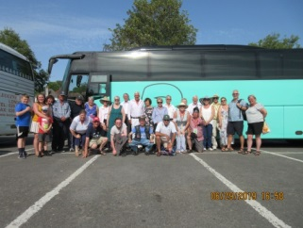 Marlborough Branch and their coach.

**Armed Forces Day Trowbridge 29th & 30th June**

The Armed Forces Weekend at Trowbridge took place on the 29th & 30th June with a marvellous parade supported by the Royal Artillery from Larkhill with over 250 personnel, bikers and 40 + marching veterans. Thank you to all Standard Bearers who attended this parade or the Drumhead Service in Trowbridge – your support was greatly appreciated. Thank you to Eddie Edwards and the Trowbridge Branch for supporting and organising the RBL Presence at this great weekend. Please see some great photos below:

 [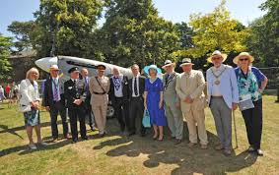](https://www.google.co.uk/imgres?imgurl=https://www.wiltshiretimes.co.uk/resources/images/8557035?type%3Dresponsive-gallery-fullscreen&imgrefurl=https://www.wiltshiretimes.co.uk/news/16693997.armed-forces-weekend-in-trowbridge-wont-change-dates-despite-25000-offer-to-do-so/&docid=mPfqj2tW_t7m8M&tbnid=wFc4ilH24AhIIM:&vet=10ahUKEwi30oG0nuTjAhURhlwKHbQ9CbgQMwhtKBswGw..i&w=1200&h=754&bih=498&biw=1350&q=trowbridge%20armed%20forces%20day%20weekend%202019%20photos&ved=0ahUKEwi30oG0nuTjAhURhlwKHbQ9CbgQMwhtKBswGw&iact=mrc&uact=8)

[](https://www.google.co.uk/imgres?imgurl=https://www.wiltshiretimes.co.uk/resources/images/6502402?type%3Dresponsive-gallery-fullscreen&imgrefurl=https://www.wiltshiretimes.co.uk/news/15369403.thousands-in-trowbridge-to-celebrate-armed-forces-day/&docid=rPD3---e9qdDMM&tbnid=uFxvbi3y5VIekM:&vet=10ahUKEwi30oG0nuTjAhURhlwKHbQ9CbgQMwiFASgzMDM..i&w=1200&h=797&bih=498&biw=1350&q=trowbridge%20armed%20forces%20day%20weekend%202019%20photos&ved=0ahUKEwi30oG0nuTjAhURhlwKHbQ9CbgQMwiFASgzMDM&iact=mrc&uact=8) 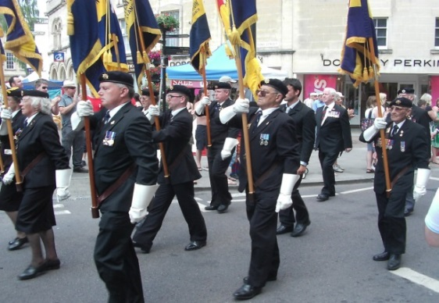

**Warminster Presentation Evening**

Warminster Branch arranged a presentation evening for the Warminster Army Cadets who raised £2907.91 for the Poppy Appeal.

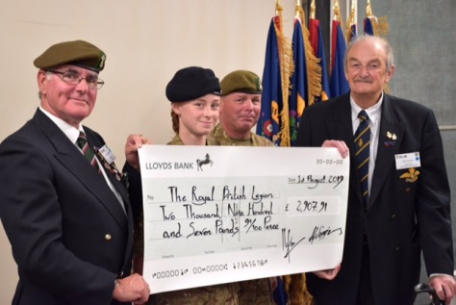

**Other News**

**Message from MSO.**

I would like to thank all branches for their hard work, support and commitment in their local areas over the year. I would also like to extend my thanks to the support I have received on what has been a difficult 10 months with ankle breckages, a personal bereavement, staff changes and sudden serious illness which has stopped some of my additional activities as MSO including the Newsletter. I would like to thank the Branch Secretaries who have greatly assisted in sending out all the email updates sent from me in the absence of a July Newsletter – your assistance is greatly appreciated. I am currently working on my calendar and will be planning dates for 2019/2020 to restart the Wiltshire Traning programme for the County among other things and am looking forward to remainder of this year at full speed