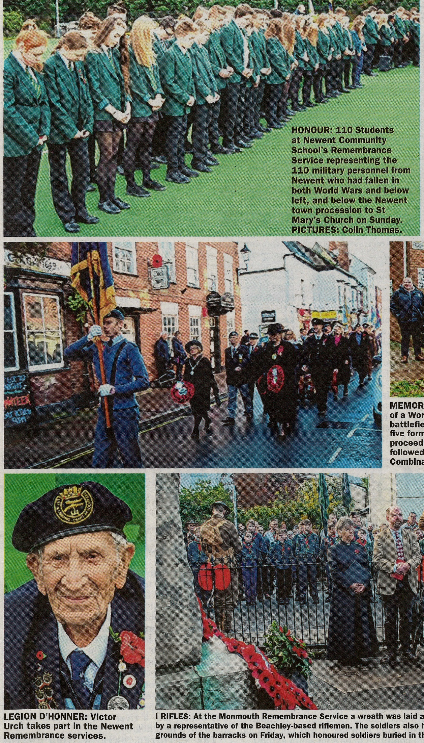

Press cuttings from Forester November 2018

- Top: Newent School Remembrance Service 9 November 2018

- Middle: Annual Parade through Newent Town 11 November 2018

- Left: Victor Urch recipient of Legion D’Honner 11 November 2018

