  Helston Cottage Hospital
  Helston and District Cottage Hospital opened on 21/05/1923 following the raising of funds by the people of the Lizard Peninsula.
  It has served as the Peninsula’s central War Memorial. During the First World War, 200 men lost their lives in service to King and Country and many more were maimed.
  The foundation stone was laid in May 1922, with the hospital opening a year later. It was re-named Helston Community Hospital in 2008.
  100 years on, our hospital still provides essential NHS services, and to the wider community in their homes.
  Special thanks to:
  Lord St Levan,
  Lord Lt Col Bolitho,
  The Royal British Legion,
  The Bishop of Truro,
  Clerical dignitaries from the many faiths,
  Mr & Mrs Benney,
  Helston Hospital’s League of Friends,
  Matron Lynda McHale
  Staff of Helston Community Hospital, past and present,
  Helston Town Band and Town dignitaries,
  The Cadgwith Singers,
  Helston School,
  Members of the Armed Forces and Cadet Forces,
  The people of Helston and the Lizard Peninsula
  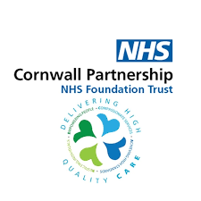
  Helston
  Community
  Hospital’s
  100th Birthday
  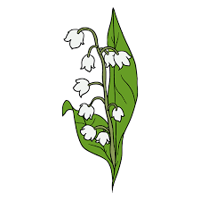
  21st may 2023
    - 2pm till 5pm

Re-dedication Ceremony  Welcome: Matron Lynda McHale  Bishop of Truro’s address:  Hymn: All People that on Earth do Dwell  All people that on earth do dwell, Sing to the Lord with  Cheerful voice; Him serve the fear his praise forth tell  Come ye before him and rejoice; The Lord ye know is  God indeed; Without our aid He did us make; we are his  Flock he doth us feed; And for his sheep he doth us take  For why the Lord our God is good his mercy is forever sure;  His truth at times firmly stood and from age to age endure.  Re-dedication prayer: Bishop of Truro  Lord St Levan: speech and unveiling of plaque  Hymn: Now thank we all our God.  Now thank we all our God with hearts and hands and voices,  Who wondrous things hath done; In whom his world rejoices; Who from our mothers’ arms hath blessed us on our way, with countless gifts of love and is ours still today;  All praise and thanks be to God, the father now be given  The son and him who reigns with them in highest heaven,  The one eternal God whom heaven and earth adore;  For thus it was, is now and shall be evermore.  Cadgwith Singers/Helston Town Band: Trelawney.  League of Friends President: Speech. |  |  | Following the Re-dedication Ceremony  the staff, past and present of  Helston Community Hospital  cordially invite you to our Garden Party.  Cream teas, cakes, facepainting, plus musical entertainment provided by the Cadgwith Singers  and Helston Town Band.

