Festival of Remembrance 2026 | Festival of Remembrance 2026

Problems viewing? Click to view online

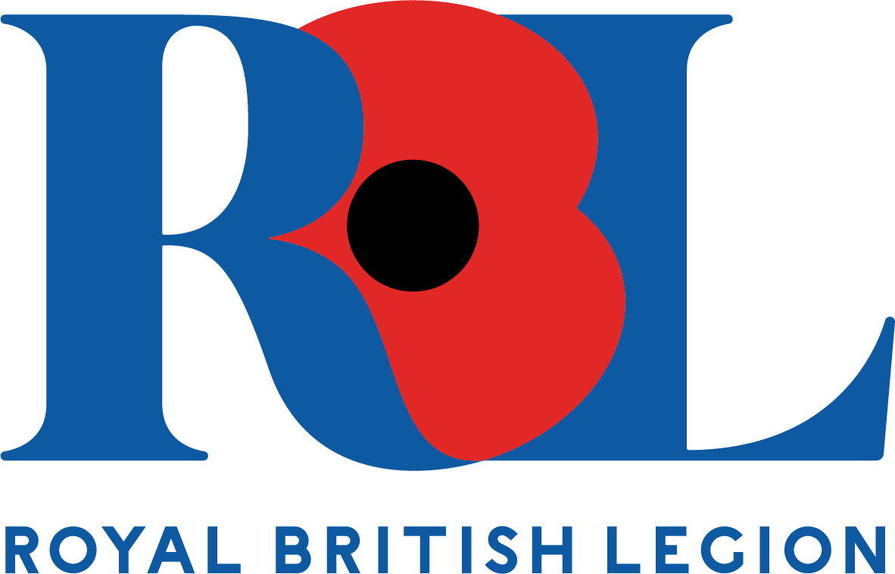

Festival of Remembrance 2026 ticketing

Dear Mr Law,

We hope this email finds you well.

Following the announcement in the eNewsletter last month, we are contacting you to provide further details about the ticketing process for the Festival of Remembrance 2026, which will take place on Saturday 7th November 2026.

Tickets will once again be allocated through a ballot to ensure all members have a fair chance to purchase tickets. The ballot opens on Wednesday 27th May 2026 and closes on Wednesday 24th June 2026.

We have taken onboard your feedback from 2025 to improve the ticketing journey.

Overview of the process:
- Members will have four weeks to enter the ballot through an online platform. This is to ensure that as many members as possible have a chance to secure tickets.
- Members will have the option to enter the ballot for either the evening performance or the afternoon performance, or both.
- After the ballot closes, tickets will be allocated randomly by our ticketing agent. Members will then be able to purchase a maximum of two tickets.
- Unique links will be issued to successful entrants one week before the booking site goes live for each performance. Once the booking site is live, entrants will be required to select their seats and will have 14 minutes to enter the details of themselves and a guest.
- Key dates and deadlines for 2026 will be communicated in the Membership eNewsletter, Central News and Legion magazine to help members stay informed.

Key changes to the ballot in 2026:
- The ballot will be open for an additional week, giving members four weeks to enter the ballot for a chance to secure tickets. This is to provide members with more time to see our communications and enter the ballot.
- Members who have entered the ballot for both performances will be informed of the outcome for each performance. We want our communications to be as clear as possible, so members are fully informed.
- All ballot entrants will be informed of the outcome of their entry one week before the booking site goes live. This allows members time to prepare the required information to purchase tickets.
- The booking site will go live for each performance on consecutive days, rather than one week apart.
- All successful ballot entrants will have two weeks to purchase tickets once the booking site goes live.

You will need the following information to enter the ballot when it opens:
- Your RBL membership number – this is the set of digits displayed above your name on your membership card (as shown below), you can also find this on your renewal letter. Your membership number contains only numbers. Please do not use your branch code (e.g. BRXXXX).

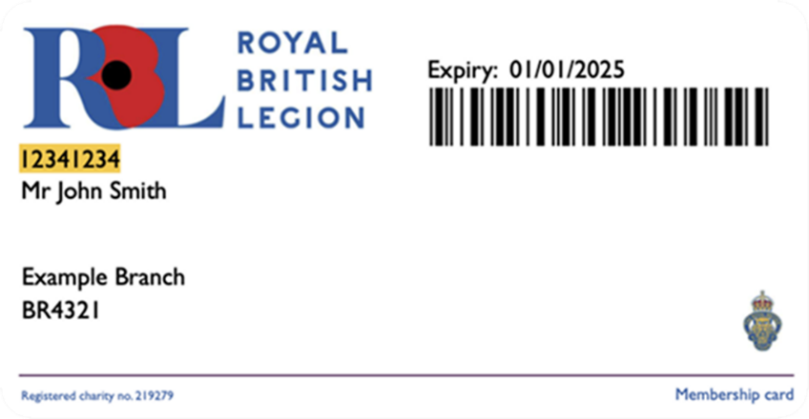

- A valid email address – ensure your registered email address is up to date, as all ballot communications will be sent via email. If you do not have your own email address, you can use one that belongs to someone else who has agreed to receive emails on your behalf e.g. a family member, trusted friend or neighbour.

Ballot rules:
- Each member is allowed to enter the ballot once.
- All entrants will be notified by email regarding the outcome of their entry.
- Unique links will be single-use and tickets must be purchased within 14 days of the date the booking site goes live.
- Other ballot rules can be found here on our website.

Please find below the key dates for 2026:
- Wednesday 27th May: Ballot opens for both performances.
- Wednesday 24th June: Ballot closes for both performances.
- Wednesday 8th July: Evening ballot is drawn and entrants informed of the outcome.
- Thursday 9th July: Afternoon ballot is drawn and entrants informed of the outcome.
- Wednesday 15th July: Booking site for the evening performance goes live for successful entrants. Members have two weeks to purchase tickets.
- Thursday 16th July: Booking site goes live for the afternoon performance for successful entrants. Members have two weeks to purchase tickets.
- Two weeks from the date the booking site goes live: Payment deadline.
- Wednesday 28th October: Tickets posted out from this date.

We encourage all members to review the process on the RBL website and keep an eye out for further updates, including the launch of the ballot in May 2026.

View the website

Thank you for your support of the RBL, our beneficiaries and our Armed Forces community.

Kind regards,
The Membership Team

