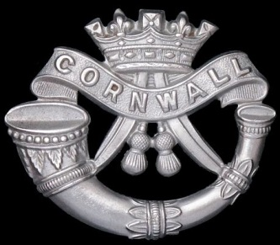
In Memory of
2872929 Serjeant George Thomas Coleclough
5th Battalion The Duke of Cornwall Light Infantry
Killed In Action on 16 August 1944
Age 34
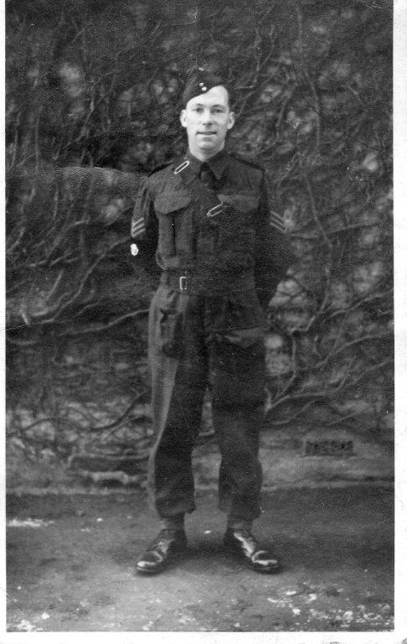
We will remember him
The story of Serjeant George Thomas Coleclough with
The 5th Duke of Cornwall Light Infantry in Normandy
214 Infantry Brigade, 43rd Wessex Division
The 5 DCLI landed on June 22, 1944, Gold Beach, near Courseulles, when the sea was so rough that the soldiers had to jump into chest-deep water and wade ashore, carrying weapons – and bicycles – over their heads. Precious items, such as photographs, were stowed under helmets.
The first action of 5 DCLI was the village of Cheux on June 26, 1944. They started the advance towards Cheux at two in the morning, in pouring rain. The roads and fields were sodden and muddy. Everything was chaotic. The anti-tank guns and the other vehicles got hold up in the narrow sunken lanes, and they arrived in Cheux without them. The troops were meant to 5 DCLI replace had withdrawn too soon – before they got there – so the village was back in German hands.
What followed on that day made by 5 DCLI famous along the entire front . In their first half hour of action, with only 20 killed or wounded, the Battalion destroyed five Panther tanks (SS Hitler Youth Division). To knock out one was a considerable achievement. To get five, manned by SS troops, was extraordinary.
Having regained and held Cheux for three days, 214 Brigade’s next task was to push on to Colleville, a strategically placed hamlet a mile to the south. The countryside here is gently undulating, but the thick hedgerows and deeply rutted lanes hampered the movement of tanks and artillery. Ripening cornfields provided cover for snipers, and the walled farms and compacts villages of Calvados favored defense. The infantry divisions inched forward, bitterly contesting each field and hedgerow.
Operation Jupiter was planned by Montgomery to draw German forces toward Caen, and aloow American troops to break out the South and then serving eastwards with resistance. More and more German forces were being brought in, and by this time 43th Wessex Division was facing seven Panzer Divisions. The 5 DCLI was in Colleville area for three days, under constant bombardment.
The Battalion’s next orders were to occupy Fontaine Etoupefour, a village near the River Odon.
A veteran : “I’ll never forget the terrifying walk down the railway line. We took all night to get there in pitch darkness, stepping over fallen telegraph poles, tangled cables and twisted rails, and stumbling into craters, with shells exploding all around. You didn’t know where the next one would fall. We look at the army map : “It’s only three miles”. But it felt like twenty. It was incredibly frightening. We crossed the River Odon, and crept on as far as Fontaine Etoupefour by moonlight. We dug slits, and spend the next day hiding there, behind enemy lines, with German patrols walking bust a few feet away. Then we got an order to go back to Colleville, so we faced the terrifying railway walk again”
Hill 112 – It’s high in meters above sea level.
Is non-descript as a topographical feature. But in July 1944, this windswept mound was of enormous tactical importance, with its wide views in every direction, especially towards Carpiquet airfield and heavily fortified Caen. Field Marshall Rommel declared: “He who controls Hill 112, controls Normandy”. One of Operation Jupiter’s goals was to take the hill at any cost.
The attack began before dawn on July 10. Unshaven and exhausted after two sleepless nights, the battalion watched the battle’s early stage from Fontaine Etoupefour, when the Brigadier Essane ordered the battalion to join the attack on July 22.
The Brigadier made no attempt to disguise the danger. Despite Allied air supremacy, the plan was to use infantry and artillery rather than air bombardment. At 8.20 pm, the 5th DCLI started to advance, under smoke, towards enemy tanks that were dug on the crest.
The British tanks hadn’t arrived in time, and the infantry were very vulnerable. Within minutes, machine-gun fire had killed nearly B Company. Mortar bombs and shells were exploding all around the Battalion. They found they couldn’t dig proper ditches through the tangled tree roots. When it got dark, the situation became even more confused. The battalion lost touch with C Company for several hours. The battalion was completely outnumbered, and the German attacks were relentless and overwhelming. They had to fight at close quarters, hand to hand. Everywhere, men were lying wounded or dying. It was a terrifying night.
During the chaos, an unauthorized order to withdraw – possibly for enemy origin – lost the battalion hard-earned ground. Communication lines had been cut, and the soldiers were exhausted, having not slept for three nights. By 3.00 pm, only one senior officer – a major – was still alive. He made the difficult decision – risking a court martial – to withdraw without orders, before the rest of the battalion was annihilated.
Hill 112 was never captured – The Germans held it until they retreated in early August. Later, when the battalion return to the hill, they found bodies heaped around partly-dug trenches, scattered across cornfield and clogging the River Odon…
For 5 days the battered Wyverns (43rd Division) were out of action. The battalion marching rather slowly back, to the designated rest area around Ducy-Ste-Marguerite, 4 miles south-east of Bayeux.
General Montgomery on 27 July ordered the Britisn Second Army to strike south from Caumont, and on the 30th to capture Mont Pinçon and to get astride the road that runs from Vire through Vassy to Condé-sur-Noireau.
For the first time the 5th DCLI were venturing into genuine ‘bocage’ country – ‘la Suisse Normande’ – heavily wooded with hills, valleys, small rivers, minor winding roads and deep narrow lanes. The Germans had had olenty of time to prepare their defences and to lay minefields.
The distance from Caumont to the commanding slopes of Mt Pinçon (365m) was only 15 miles – butit was good ambush country and the 5th DCLI were going to have a number of very nasty little battles before they got there. In the bocage countryside the battle broke down into a series of ferocious individual actions, impossible to coordinate or control.
On 3rd August, 5th DCLI progressed to Jurques and were ordered to clear opposition around the village. The Cornwalls had been opposed by eight to ten tanks – Tigers and Panthers of 10th SS Division, who had retreated from Esquay area near Hill 112. Tey were firmly dug on “Tiger Hill” and the 5th DCLI had suffered another blooding, twenty dead, sixty-nine wounded and ten missing in one day.
Although the summit of Mt Pinçon had been taken there was one more battle to be fought on the lower slopes. Around La Varinière crossroads intense, continuous and accurate shelling still rained down. The new objective was the capture of the straggling village of Le Plessis Grimoult.
Late on the afternoon of 7 August, Brigadier Peter Essame arrived at the 5th DCLI HQ and said to their CO : George (Taylor) I want you to capture Le Plessis Grimoult, an important communication center at the southern foot of Mt Pinçon. Colonel Taylor called it Operation Matador, which turned out to be one of the classic and successful operations in Normandy.
George Taylor recalls: ‘It was now dark. Suddenly there was a deafening explosion as an enemy ammo store exploded in a fury of gold and red flame. This magnificent bonfire acted as a beacon for the attack. The night was alight with tracer bullets but heavy mortar fire was coming down on our tank’. At 1010hrs the silent Cornwalls entered from the north as the barrage stopped. Although theit PIAT’s has been destroyed while forming up, Major Parker ordered his 2-in mortars to fire, plus every other weapon, at two enemy tanks in the center of the village. A motar shell landed on an ammunition lorry replenishing the tanks, and ten second later one of them was enveloped in flames and the second withdrew southwards.
It was close quarter work and a lot of grenades were used. George Taylor again : ‘After an hour’s fighting the defence collapsed. I will never forget the sight of enemy prisoners being marched down the village street by the glow of burning houses. German dead (thirty-one) and wounded lay scattered about. The village had been held by two rifle companies. We captured 125 of them and our losses were two men killed, one missing and five wounded. No tanks of ours were knocked out’.
Operation Blackwater. This was the codename for the final phase of the Wyvern’s advance southwards from Mt Pinçon towards the River Noireau, there to form a bridgehead.
There were signs that the enemy was withdrawing, slowly but inevitably against the enormous Allied pressure. By the morning of 11 August by the high ground overlooking the River Druance, 5 miles south of Mt Pinçon, was secured by 214th Brigade. On the left 50th Tyne and Tees Division too was pushing south from Cauville toward St Pierre-la-Vieille and the high ground beyond. 129th Brigade had entered Cauville and pushed another mile south-east. The next day it was the turn of the 7th Somersets to take neighbouring Mt Gaultier and the Cornwalls tooccupy La Trulandière village near Culey-le –Patry.
On 14th August, General Thomas planned to cross the River Noireau near Cahan where there were road and rail bridges. A long plateau dominates the north bank of the river with a network of parallel roads running esat-west. The Noireau is a small tranquil stream with steep wooded heights on top of wich are the three fortified village of Berjou, Le Canet and Le Hamel. The objectives now given to the 214th Brigade was a track winding obliquely from near the railway station leading up to the village of Berjou on the crest, then 2 miles south-east to Point 237. The crossing of the river had to made in two places, one near Berjou railway station at Les Bordeaux, the other beside a factory at La Rocray. The river was 20yds wide, about 3ft deep – thus impassable for vehicles. The divisional gunners were situated at Grand Beron and to rear of Les Bruyères-de-Clécy.
The Worcesters started off at 1830hrs and waded across the river near the blown railway bridge under the heavy barrage. Despite a shower of mortar bot midsummer evening, they pushed up the steep track through woods that very hot midsummer evening, clearing Teller mines on their way.
The next day they saw evidence of the tremendous support fire put down by 8th Middlesex 4.2-in mortars and MMG-several hundred German dead were counted in the area.
The Cornwalls now followed up behind the Worcesters. By darkness George Taylor had made contact with Major Watson of yhe Worcesters and ‘the Cornwalls dug in forming a solid triangle on the edge of the plateau. Six companies were sited cheek by jowl only 80 yds away from the enemy. They harassed us with mortar fire and losses among the Worcesters began to mount’. But no artillery support as the heavy wireless sets could not be carried up the hills, no vehicles, no tanks, and no anti-tank guns had yet croosed the Noireau.
On the morning of the 16th August determined enemy rearguards of the 986th Grenadier Regiment launched – predictably – counter-attacks, as George Taylor recounts :
The BRRRRRRRRRRRRP of the deadly fusillade of MG 42s sited in depth – the sound of a giant tearing up monstrous playing cards in his powerful hands. They began with an infantry attack on left-hand company of Worcesters. Major Matthews, their CO, was badly wounded in the arm. Casualties were mounting among the DCLI and Worcesters and a steady stream of men were being evacuated from left to right in front of the wood. The edge of the wood became a death trap. The Germans attacked on the extreme right of ‘D’ Coy. They could now cover the crucial track leading down the hill. Communication to the rear was cut off. Just in time a welcome roar from behind as the leading tanks of the Sherwood Rangers arrived.
The gunner FOOs were now on the top of the hill so the two battalion commanders of the Worcesters and of the Cornwalls, hatched their battle plan. The Worcesters would capture Berjou where an entire enemy company were dug in with twelve tanks or SP guns while the Cornwalls would clear the left edge of the ridge including a troublesome hump which dominated the whole area – as George Taylor relates :
‘Brigadier Essame approved my plan, said increased fire power would be available to support the Worcesters’s attack. ‘A’ Company took the ridge at “Les Monts” supported by tanks. A large number of the enemy were killed or captured in the process. In farm on the plateau lay the bodies of five of our men. Around them were nineteen dead Germans. Covered by the great artillery barrage, the Worcesters swept forward, taking Berjou and a considerable number (sixty) of prisoners’.
Serjeant GeorgeThomas Colecloud was one of these five brave men.
Some years after war, the bodies of the 5th DCLI buried in the battlefield of this part of Normandy were reburied at CWGC Banneville la Campagne Cemetery.
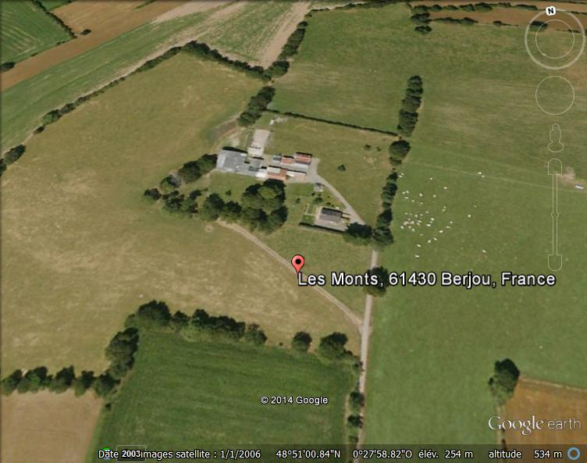
La Ferme “Les Monts” à Berjou

